Physical activity in parks –

Community group licence

Application form

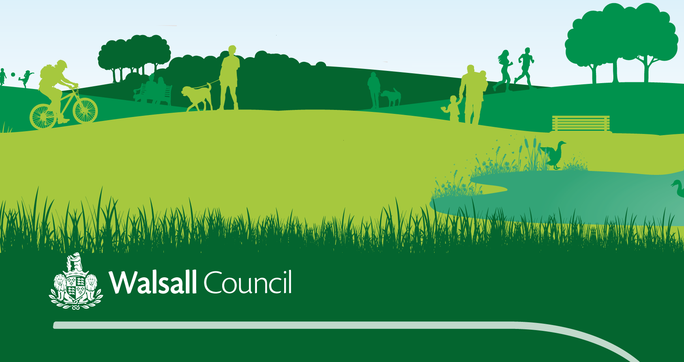

Those wishing to deliver organised community free activities (such as fitness sessions, sport, or wider learning opportunities) in parks and greenspaces, must seek permissions and the appropriate licensing from the relevant local authority (the landowner). This could be to the public or defined groups.

This licence safeguards your organisation as a reputable, qualified and insured training provider, and allows us as a council to market and promote your session to the wider community.

Use is still for free but permission needs to be sought

Wider conditions of the licence

* Ensure Activities do not impact on wider council activities, other approved activities or the public in general.
* Activities are conducted at all times upon the area in a manner which is not an annoyance, nuisance or disturbance to other users of the facility including other trainers and nearby residents.
* Be conscious of keeping noise levels to a minimum, particularly in the evening
* Ensure the facilities are left clean and tidy
* Those involved in fitness activities must not use picnic tables, seating, street furniture, fences, walls, shade shelters, trees or other structures as training aids and must not damage any natural assets such as dressed areas, vegetation, trees, shrubs and the like.
* Training providers may provide appropriate equipment and such equipment shall be in good order and repair. Heavy equipment that may damage the environment in which it is used is not permitted.

Accreditation

* All deliverers should have and maintain appropriate suitable qualifications with the following minimum expectations
* Accredited as a fitness trainer / coach / instructor / session lead specific to the type of activity to be conducted; and,
* A current first aid certificate

# SECTION ONE - GROUP DETAILS

Name of organisation: Click or tap here to enter text.

Organiser: Click or tap here to enter text.

Deliverer / coach / instructor: Click or tap here to enter text.

Contact address: Click or tap here to enter text.

Postcode: Click or tap here to enter text.

Tel No (work / home): Click or tap here to enter text.

Tel No (mob): Click or tap here to enter text.

Fax No: Click or tap here to enter text.

E mail address: Click or tap here to enter text.

Social media pages / links: Click or tap here to enter text.

# SECTION TWO - ACTIVITY DETAILS

**NAME OF SESSION / s:**Click or tap here to enter text.

Venue / s: Click or tap here to enter text.

Date from / to: Click or tap here to enter text.

Description of proposed activity: Click or tap here to enter text.

Is this a (please tick relevant box)

Community session/event ¨ Charity session/event

Days and times of delivery

|  |  |  |  |  |  |  |  |
| --- | --- | --- | --- | --- | --- | --- | --- |
|  | **Monday** | **Tuesday** | **Wednesday** | **Thursday** | **Friday** | **Saturday** | **Sunday** |
| Time | Click or tap here to enter text. | Click or tap here to enter text. | Click or tap here to enter text. | Click or tap here to enter text. | Click or tap here to enter text. | Click or tap here to enter text. | Click or tap here to enter text. |
| Time | Click or tap here to enter text. | Click or tap here to enter text. | Click or tap here to enter text. | Click or tap here to enter text. | Click or tap here to enter text. | Click or tap here to enter text. | Click or tap here to enter text. |

Approximate number of people expected to attend: Click or tap here to enter text.

# SECTION THREE – KEY DELIVERY SAFETY CHECKLIST

To register an activity delivered for **adult (16+) participation** please complete sections **A, B and D**

To register an activity for **junior (under 16) participation** please complete sections **A, C and D**

For activities which are open to both **adults and juniors** please complete sections **A, B, C and D**

# Section A: Essential criteria for all activities

* **Are you insured?**  **Yes** ¨ **No**
* **Are you equitable?** We are committed to the promotion of equality and diversity regardless of age, gender, disability, religion or cultural background. *Tick to agree*
* **Risk Assessments** – have risk assessments been completed for the delivery?  **Yes** ¨ **No**
* **Litter collection** - please state how you will maintain the park free of litter and rubbish during the session and after it has finished

Click or tap here to enter text.

# Section B: Activities for adults (16+)

* **Are your participants safe?** Please state what first aid provision is in place for the activity:

Click or tap here to enter text.

* **Is the activity coached or instructed?** If yes, please list delivery qualifications and awarding bodies that staff hold to cover your delivery:

|  |  |
| --- | --- |
| Qualification type / level | Awarding body |
| Click or tap here to enter text. | Click or tap here to enter text. |
| Click or tap here to enter text. | Click or tap here to enter text. |

# Section C: Activities for juniors (under 16)

* **Are your participants safe?** Please state what first aid provision is in place for the activity:

Click or tap here to enter text.

Please tick to confirm that you record the emergency contact details and any medical conditions of the children under your supervision

* **Are relevant DBS checks in place?** All people regularly involved in the delivery or organisation of junior activities should have a DBS check at appropriate levels. Please confirm that a DBS check has been completed for all deliverers  **Yes**  **No**

Are arrangements in place for checks and renewals? **Yes**  **No**

* **Are coaches or instructors suitably qualified to deliver the activity?** Please list delivery qualifications and awarding bodies that staff obtain for your delivery:

|  |  |
| --- | --- |
| Qualification type / level | Awarding body |
| Click or tap here to enter text. | Click or tap here to enter text. |
| Click or tap here to enter text. | Click or tap here to enter text. |

* **Is there a suitable child protection policy and procedures in place?**

Please tick to confirm that all people involved in the delivery or organisation of the activity are aware of how and where to report a child protection issue

# Section D: Declaration

I must notify the Healthy Spaces Team if I have any safeguarding concerns about my group/ organisation’s lack of adherence to an effective safeguarding policy (this applies if you are providing services for children under 18 and / or vulnerable adults).

I will undertake to inform the above if I, or my organisation / group have any concerns about any adult associated with the activity in respect of safeguarding.

I understand that failure to do so could result in a termination of the agreement.

I will ensure there are signing in / signing out arrangements, to ensure that those using the premises / sites have vacated at the end of the session.

I confirm that all the information provided by myself, or my organisation in the form above is accurate.

Signed



Name Click or tap here to enter text.

Position in Organisation Click or tap here to enter text.

Date Click or tap to enter a date.

Please send this completed form, together with all supporting documentation to:

[*healthyspaces@walsall*.gov.uk](mailto:healthyspaces@walsall.gov.uk)

**Office use only**

Building / Site induction undertaken? ¨ **Yes** ¨ **No**

Healthy Space Staff sign / date to confirm when completed: …………………………………………………………………………………

For more information please contact the Healthy Spaces Team on

01922 653344

*200 Pelsall Lane,*

*Brownhills,*

*Walsall WS8 7EN.*