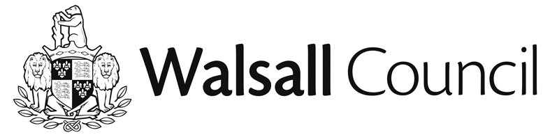

LOCALISM ACT 2011
ASSETS OF COMMUNITY VALUE
NOTICE OF INTENDED DISPOSAL OF LISTED LAND
THE FOUR CROSSES PUB, GREEN LANE, SHELFIELD, WALSALL, WS4 1RA

NOTICE is hereby given that on 03 July 2015 the Council received notification from the Receiver c/o Baker Tilly Restructuring and Recovery LLP pursuant to section 95(2) of the Localism Act 2011 (‘the Act’) that it intends to dispose of (i.e. sell) the Four Crosses Pub (“the Property”). The Property has been listed as an asset of community value since 20 December 2013.
Any community interest group (as defined in the Act and the Asset of Community Value (England) Regulations 2012 (“the Regulations”) may now make a written request to be treated as a bidder for the Property. Such requests must be made before the end of the interim moratorium period, which expires on 14 August 2015.
If any community interest group makes a written request then a full moratorium period will come into force, expiring on 3 January 2016.
During the moratorium periods the owner may not dispose of the Property other than to a community interest group (unless the intended disposal falls within an exemption identified in the Act or Regulations).
If no sale to a community interest group is agreed during the applicable moratorium period, then the owner will be free to sell the Property on the open market during a protected period expiring on 3 January 2017.
Any community interest group wishing to be treated as a bidder should contact Jay Patel at Walsall Council, Resources Directorate, Communities & Public Protection, 2nd Floor, Zone 2C, Civic Centre, Darwall Street, Walsall, WS1 1TP, Righttobid@walsall.gov.uk

Walsall Metropolitan Borough Council
Civic Centre
Darwall Street
Walsall
WS1 1TP

06/07/2015

