WALSALL SAFEGUARDING PARTNERSHIP  Multi-Agency Referral Form  (MARF) | 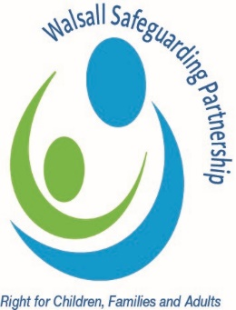
For use when making referrals into the
Multi-Agency Safeguarding Hub (MASH)

This form should be used to make a referral to Walsall Children’s Social Care.
Please ensure that ALL FIELDS ON THIS PAGE ARE COMPLETED IN FULL
Where you believe there is immediate risk of significant harm, please contact the police.

All urgent child protection referrals should initially be made by telephone on 0300 555 2866 Option 2
(Out of hours – 0300 555 2922) and then confirmed in writing as soon as possible within 24 hours.
The completed form should then be sent by email to MASH@walsall.gov.uk Please refer to the Right Help, Right Time threshold guidance – The multi-agency guidance on the continuum of need
Please only complete this MARF when you are requesting a Statutory Response – Level 4. For any referrals that require Early Help Support, please refer to the Early Help Pathway – Early help
If your concern is in relation to a Child or Young Person who is being Exploited, please complete the Exploitation Assessment instead of the MARF, this can be found here

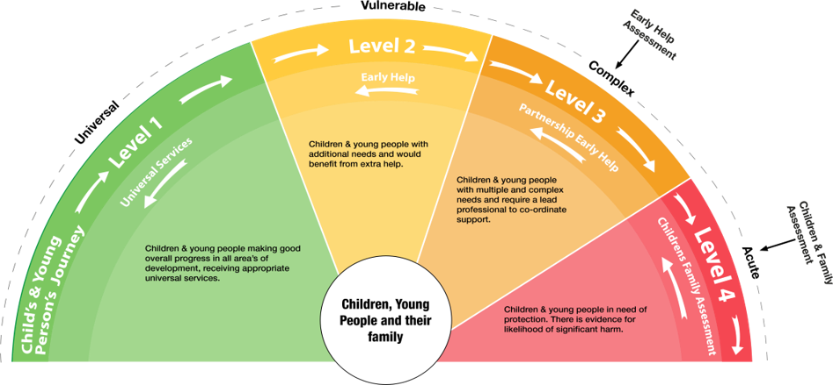
Right Help, Right Time: Continuum of Need

REFERRAL DATE |  | TIME

Details of Referrer
Name
Designation
Organisation
Address
Post Code
Email address
Tel No

Have you consulted with the Designated Safeguarding Lead for your agency prior to submitting this MARF?
Provide, name, date and time and advice or plan decided
SIGNATURES | Person Making Referral | Designated Safeguarding Lead /  Line Manager
Print Name
Signature

CONSENT
At every stage of need, professionals must discuss their concerns with the family and request consent to share information to get the right help and support at the right time unless doing so will significantly increase the risk of harm to the child.
If parental consent is not obtained, this referral will not be processed and will be closed to MASH unless there is evidence of significant harm to a child or young person.*
In the absence of parental consent, parents/carers will be notified by MASH of the receipt of this referral and informed that no action will be taken and to contact the referrer for further information/support if required.

Has parental consent been obtained to submit this referral?  (By obtaining consent, parents would be consenting to checks with agencies across the partnership) |  | Yes |  |  | *No |  | Written or Verbal  (Delete as appropriate)
*If consent has NOT been obtained, please discuss your concerns with the parents/carers and obtain consent for referral before sending this MARF.
If consent has not been obtained due to concerns for the child’s safety, please give reasons here.

Do you consider that the child/young person is at IMMEDIATE RISK OF HARM?
YES |  |  |  | NO

Unborn / Child / Young Person
Child Forename | Child Surname | Gender | Date of Birth/EDD | NHS Number
if unborn baby - Hospital where booked
Address: Include all addresses where the child/ren reside |  | Telephone Number:
Ethnic Origin
1st Language
Is an Interpreter required?
Religion/ Belief

Parent /Carer Details
 | Person 1 |  | Person 2
Forename
Surname
DOB
Relationship
Address
Telephone Number
First Language
Is an Interpreter / Signer required?

Other Household Members
Forenames |  | Surname | DOB |  | Relationship |  | Also referred?  Enter Yes or No
What you are you worried about? (explain the current worries you have for this child or young person’s safety or well-being)
Please refer to the Right Help, Right Time threshold guidance and highlight level 4 indicators.
(The multi-agency guidance on the continuum of need)
What is the impact upon the child? (Within this section, think specifically about the impact upon the child, what are their lived experiences?)

Voice of the Child (does the child feel safe, what have they said or done, behaviour around family etc. consideration to use of alternative communication to methods and observations, interactions with parents/carers for non-verbal children)

What is working well?
(Examples - there is existing support, they are attending school, parents are engaging, good support network, child’s presentation is clean and tidy, they are attending medical appointments etc.)

Significant history / relevant information
(Previous involvement with statutory services, parents not engaging or possible disguised compliance, poor school attendance, not attending medical appointment or delays in seeking medical attention, poor presentation of child dirty, unkempt, ill-fitting or inappropriate clothing etc.)
What needs to happen next?
(What do you think needs to happen with this referral, analyse your concerns and desired outcomes)

Please outline any services that have been provided to address any previous concerns prior to this referral.

Has an Early Help Assessment been completed? | Yes |  | Lead worker details
If so, provide copy | No |  | Why not?
Has a GCP2 (Graded Care Profile) been completed? If applicable. | Yes |  | If yes, please indicate outcome and attach a copy.
 | No

Are you aware of any other agencies involved
(e.g. GP, Health Visitor, School Nurse, CAMHS, Youth Justice Service)
Name | Designation |  |  | Address |  | Tel

