

Improving Lives and Making a Difference
Walsall Council’s
Local Account for 2011-13

Version Control: Final version
Date: 2nd October 2013
Document Owners: Strategic Development
Edited by: Nigel Imber, Strategic Lead Officer
Karen Houghton, Programme Office Facilitator

Contact: Strategic Development
 strategicdevelopment-sci@walsall.gov.uk
 01922 658367

CONTENTS

ITEM | Page No.
Executive summary | 5
Setting the scene including key facts and figures | 8-11
Our achievements during 2011/12 and 2012/13
- Enhancing the quality of life for people with care and support needs |  | 13
- Delaying and reducing the need for care and support |  | 20
- Ensuring that people have a positive experience of care |  | 30
- Safeguarding adults whose circumstances make them vulnerable and protecting them from avoidable harm |  | 34
Consultation Activity |  | 39
Our Priorities for 2013/14 |  | 41
Further Detailed activity Information |  | 48-52
Appendix 1 Case studies |  | 53

FOREWORD

Walsall’s Local Account

This report has been produced to tell people who live in the Borough of Walsall what has been happening in social care services for adults and older people and what may be happening in the future. We always welcome your comments on what you think of the services we arrange and provide, and we would be pleased if you want to comment on this Local Account. You can do this by sending an email to strategicdevelopments-sci@walsall.gov.uk or by writing to Strategic Developments SC&I, Room 17a, Council House, Lichfield Street, Walsall, WS1 1TP

Summary

In 2011/12 the council spent £115 million on care for older people and younger adults with care needs in Walsall. This was £4 million less than we had spent in the previous year and £11 million less than the year before that. You can see from these figures that the money available to us to spend on adult social care is reducing – that is because the government has reduced the level of grants it gives to local councils including Walsall. We know that the amount of money that is spent in Walsall on adult social care will continue to decrease over the next few years as the grants from central government will also continue to reduce.

People who received services made a financial contribution of just over £9 million towards their costs in 2012/13, which is almost identical to the sum of money they had paid overall in the previous year. That is because social care is not free – everyone who receives a service has a means test to assess if they can afford to make a contribution. In Walsall we had introduced “benefits-based charging” which means that if someone gets benefits to which they are entitled because they have a disability, part of this money has to be used as a contribution towards the costs of the care they need.

Most of our budget (60%) was spent on providing care for older people. We helped 3,000 older people continue to live in their own home and a further 550 people in residential or nursing care homes. Most of the older people we help are over the age of 85, live alone and have had a period of ill health.

We also helped 426 adults with learning disability receive support in the community.

About half of those we help now have a “personal budget”. This means they know exactly how much money there is available to help meet their care needs. By the end of next year we expect everyone to know how much money is available for them to pay for the care they need. We also want to increase the number of people who take this personal budget in the form of a direct payment – where they manage the money available to them for themselves (sometimes with assistance from a support organisation). Currently about a quarter of people who are eligible for care services in Walsall organise their own care in this way.

For next year, even though we will have less money, we want to make a new offer to local citizens. This is based on ensuring people get early help and a clear intervention when they come to us in a crisis. We want to be quicker at helping people who are leaving hospital, or assisting people who are at risk of social isolation or have other care needs. We will develop a set of services that enable us to respond quickly – but these services are designed to assist people in the short term in such a way that many will not need longer term care and support. This might typically help an older person who is not well to recover and get back on their feet but it won’t offer on-going services. We will expect people do some things more for themselves, such as taking an exercise programme that will help their recovery; or to support a person with learning disabilities to be travel-trained when they haven’t previously learned how to use public transport.

Our prime objective will be to help people to live as independent a life as is possible for them with as little help as is practicable for them to live a fulfilled life. We call this our “new operating model”.



John Bolton
Interim Executive Director

WHAT IS A LOCAL ACCOUNT?

Local Accounts are produced to help people see how adult social care services are doing in their local area. The Care Quality Commission (CQC) no longer undertakes annual performance assessments of council adult social care services. Councils are instead encouraged to assess their own performance and publish information about how they are performing, which is done through this document.

The Local Account is designed to use as a tool for self-improvement. It is at the heart of the new model for sector-led improvement introduced by the Government in their consultation response “Transparency in Outcomes: A Framework for Adult Social Care” (March 2011).

The Local Account is not statutory and there are no specific requirements about what it should include. The Council has therefore decided the content of this report by using guidance and our own interpretation of what might be useful to know. The Council sees this second Local Account as an opportunity for us to engage with you and to use your feedback to develop and improve the report over the coming year.

SETTING THE SCENE
It is predicted that by 2030, 58,000 people (almost one quarter of Walsall’s population) will be aged 65 or over. This challenges adult social care to change the way in which it delivers services. With pressure from care homes and home care providers to reflect rising costs in the prices paid for care, charges to people who use services, often already at the maximum permitted level, rising demand and a downward trajectory for councils' funding, there is a clear and pressing need to transform adult social care services.

In addition, due to the global economic crisis, and the impact of public austerity, adult social care has less money to spend. Between 2011/12 and 2013/14 a total of £19.316m savings were achieved by adult social care: £8.823m for 2011/12; £7.155m for 2012/13; and a target of £3.338m for 2013/14. These have been made in a number of ways including the restructuring of teams, a programme of supporting Walsall people back into the borough from residential care provision out outside of Walsall, and maximising income through methods such as benefits based charging. Despite this enormous financial challenge adult social care will support more people and give them greater control over their care and support.

The Council will continue to implement its strategy to plan and deliver preventative services, with particular emphasis on accessible services from within the voluntary and community sector to support people and prevent or reduce the need for social care services. During 2011-13 the Council has placed an increasing emphasis on using the latest technology to support people in their own homes, which not only helps them feel safe and secure but also maintains their independence.

Increasing numbers of people with complex learning disabilities have required our support during 2011-13 and, in line with national trends; Walsall faces growing numbers of older people and people with dementia.

To meet this demand the council has realigned its access, assessment and care management service, and redesigned its provider services to focus on reablement and prevention. By promoting independence among people and ensuring stronger partnership working between the services areas who initially assess people and those who provide support, duplication of support roles/work is being reduced and to date has saved £3m.
During 2011/12 a new policy was approved and implemented to redefine contributions made by people to the cost of the care and support they receive from the council. The contributions are based on what disability related benefits a person receives and this has generated an extra £3.5m for the council. This income has meant that the council has not had to make such large reductions in front line services, which people rely on for their care and support.
The council’s adult social care service has been able to invest in service improvements at the same time as making cost and efficiency savings, by providing services that enable people to regain their independence and get them back doing the things that they would normally do, which reduces the need for long term care services such as residential and nursing care.

The services broad aims are to improve the quality of services, maximise independence and good health, and reduce levels of spending to achieve “best in class” when compared with similar councils. This is being achieved by

- Signposting people to universal services including a range of community based health and social care services, preventing people from becoming socially isolated and needing more intensive and costly health and social care services through a range of practical services close to home
- Providing disabled facilities within mainstream services such as a disabled shower facility in a leisure centre
- Ensuring that people in crisis receive short term support based on rehabilitation and reablement, reducing their need for long term care and support
- Reducing reliance on residential and nursing care and reinvesting these savings into further prevention services to ensure that we can meet the demand of the increasing older population
- Redesigning business support and processes, for example reducing staff accommodation, providing laptops and mobile working, reducing duplication and paper based processes, and changing our IT systems (for example numerous internet based applications to help people and providing online procurement and ordering systems for staff)
The transformation of adult social care services in Walsall follows the underlying principles of the anticipated new legislation for social care which will be based on the Care Bill currently in parliament. This modernises adult care law and includes new duties on local authorities. Work has already taken place in Walsall regarding the requirements, in particular to:
- Improve how we provide a wide range of information and advice
- Commission more preventive services
- Promote a market of diverse and high-quality services
- Make enquiries into suspected abuse or neglect of adults with care and support needs
- Establish the safeguarding adults board to oversee local safeguarding arrangements
The new legislation will make it much clearer as to what Walsall People are entitled to from adult social care by
- Assessing adult carers and provide support for those who meet eligible needs
- Complying with a new national minimum threshold for care and support
- Ensuring continuity of support for people who move between local authority areas
It also introduces a cap on what people have to pay for social care and increases the amount of assets people can retain before having to contribute to the costs of their care. It will also include a national minimum level of eligibility for support, and carers will have a legal right to an assessment for care for the first time

The Council spent £115.268m on social care services during 2011/12, which reduced to £108.199m during 2012/13.

This was spent on the following client group areas:

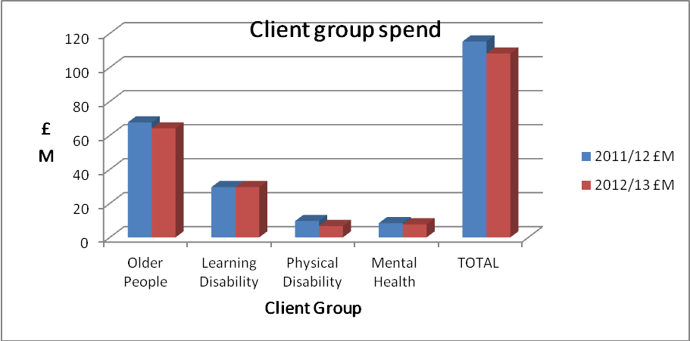

Who did we help?

During 2012/13, Social Care and Inclusion:

People who contacted us or needs we assessed
Responded to 15656 people contacting the department.
Undertook 2549 assessments for social care service.

People who we enabled to live independently
Enabled 3115 people to be supported at home
Provided 1251 people with Direct Payments and self directed support, enabling them to be in control of their care choices.
Supported 485 people with a learning disability to live in their own accommodation.
Supported 2409 people with a physical disability to live in their own accommodation.

People in residential and nursing care
Provided 1212 people aged 65+ in residential and nursing care.

Support to carers
Assessed the needs of 1350 carers
Provided 705 carers with respite services or other specific carer support services

The Social Care Workforce

The social care workforce equates to 4816 staff, approximately 4,000 staff are employed within the private and voluntary sector and 816 staff employed by the Council.

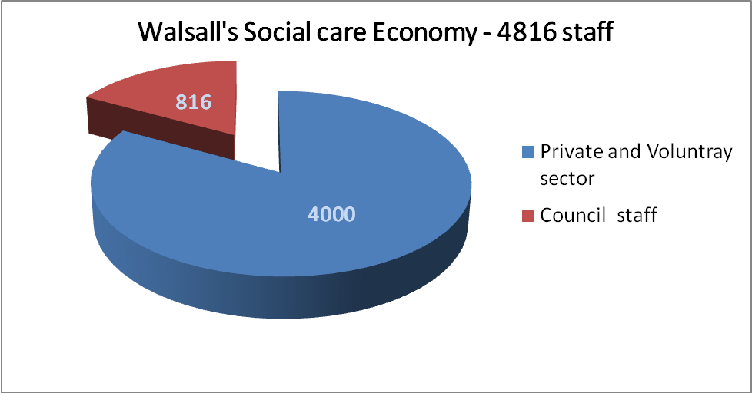

The Council has 816 of staff in its social care workforce, broken down as follows

- Provider services 329
- Assessment and care management 165
- Strategic Development 165
- Reablement staff - intermediate care 67
- Commissioning (Local authority) 13
- Workforce Development 10
- Quality and Assurance 7
- Mental Health trust 60

OUR ACHIEVEMENTS DURING 2011/12 AND 2012/13

Measuring our progress against the Adult Social Care Outcomes Framework

Walsall uses the Adult Social Care Outcomes Framework (ASCOF) a key tool to track both local and national progress towards the transformation of care and support.

ASCOF measures outcomes from across 4 areas which the council believes are the most important to you.

These are:

- Enhancing the quality of life for people with care and support needs
- Delaying and reducing the need for care and support
- Ensuring that people have a positive experience of care
- Safeguarding adults whose circumstances make them vulnerable and protecting them from avoidable harm

The sections that follow are based on these outcomes, and provide examples of what we have done to help us achieve them.

Enhancing the quality of life for people with care and support needs
This will mean that
- You can manage your own support as much as you can so that you are in control of what, how and when support is delivered to match your needs.
- You can balance your caring role and maintain your desired quality of life If you are a carer
- You are able to find employment when you want, maintain a family and social life and contribute to community life, avoiding loneliness or isolation.
Examples of what we have done to achieve this are:
Care and support needs for people with autism are reducing through improved signposting to appropriate services, and better advice, guidance and support for families and carers
An autism group has been established to enable people to come together, to seek mutual support, share their experiences and seek guidance and support from professionals with regards to autism. By raising the understanding of autism across Walsall, for example through a series of public events, adult social care is ensuring that people with autism are supported to manage risks that may be associated with their condition. This has reduced the need for statutory care and support for those with Autistic Spectrum conditions as work is undertaken with people to identify solutions which work for them, signposting them to services suitable for their and their families’ needs.

Examples of these services are:

  - A befriending scheme led by a dedicated coordinator, which has 20 trained volunteers. To date 30 people with Autism accessed the befriending service. This has been successful in areas such as:
    - Increasing their confidence,
    - enabling them to access other services,
    - helping people avoid people getting into trouble with the criminal justice system
    - Enabling carers to take a break.
  - Social groups have also been established, which meet monthly in the evenings or at weekends using and accessing social care resources. Autism Action Walsall developed a social support group, which now supports 15 people with autism, their families and carers.
A diagnostic service has been established that provides up to 25 assessments a year. During 2012/13 6 people were diagnosed with Autistic Spectrum Conditions during. This service has been vital in reducing stress and anxiety for the individuals needing a diagnosis, and their families, who previously had been unable to get one.

Walsall people are more prepared for future employment within the social care workforce by being provided with training and work experience opportunities

In 2011, Adult social care commenced its apprenticeship scheme, in collaboration with Walsall Adult and Community College. The scheme aims to develop a local high quality, trained workforce available to the whole social care sector over a two year period. This includes the council, private sector organisations, partner agencies and the voluntary sector.

During 2011/12, 37 apprentice reablement officers were recruited, with an additional 51 being recruited during 2012/13. Of these 80 apprentices it is anticipated that a significant proportion will gain future employment within the social care sector.

People with disabilities and mental health needs are supported to improve their health and well-being and reduce their social isolation by adult social care providing employment opportunities
Recruitability Plus is a pre-employment scheme that provides funding for people with physical, sensory or learning disabilities to enable them to acquire skills needed to be employed in any line of work. It enables skills development and confidence building, thus enhancing self esteem. A range of establishments have offered placements including Community Centres, leisure centres, Walsall Art Gallery, the council’s Human Resources, legal services and Street Pride, as well as external partners such as Housing21. The establishments that offer placements benefit from motivated individuals who make a significant contribution to their teams and services.
The number of people with serious mental ill health issues helped to find employment has been increased over the last two years. In 2011/12 43 people were supported to gain employment, with this rising to 55 in 2012/13; 15 of these secured an extension to their contracts.
This programme has helped Walsall to be one of the leading local authorities for employing people with learning disabilities in England as measured by National Indicator 146 (adults with learning disabilities in employment). As at March 2012 Walsall was the second best across the
Midlands’s authorities for employment and well above the national and regional averages

Feedback from placements during the review process has provided evidence of a visible increase in confidence and self esteem, and development of skills required for a particular post. In many cases, skills development exceeded what was anticipated.

Between 2011-13 adult social care provided 75 Recruitability Plus placements including 45 for people with learning disabilities, 15 for adults with Autistic Spectrum conditions, and 10 for people with physical or sensory impairments.
An outcome from these projects is that 8 people with a disability have gained meaningful permanent employment in 2011/12:
- J was employed as a leisure assistant. Following completion of 12 month training contracts, and the experience and skills gained on Recruitability Plus, J was successful in obtaining a post of full time leisure attendant in another organisation
- M was employed as an administrative assistant and is happy and settled
- C was employed as a trainee education assistant
- C was initially employed as an administrative assistant then secured a similar role within the education sector
- G was employed as a gardener then moved on to a role covering wider maintenance responsibilities
- J was initially employed as a service assistant working within Welfare Benefits. Despite suffering with social anxieties, the confidence and skills acquired through the Recruitability programme allowed J to successfully gain employment as an office assistant within a voluntary sector organisation
- P was employed within the ICT sector and went on to complete further NVQ qualifications
- B was employed as a handyperson within a community centre and is doing well
A range of services continue to be developed, which provide employment opportunities. Recent initiatives include a food bank hub that co-ordinates the delivery of food parcels to 6 crisis centres across Walsall; a data archiving and retrieval service; a Telecare installation service, all of which operate from a central employment resource centre.

The organisation called Landau provides Job Coaching for adults with a disability. The programme provides 6 months support for each person with a further 3 months that can be requested. The support to those individuals continues after they enter employment.

In total 17 people have accessed Landau since September 2012 and as at March 2013 7 continued to be supported by them.
Of these 17, 1 person is on a catering apprenticeship; 2 are studying at college; 1 is doing gardening work and 2 are doing voluntary work Adults with learning disabilities are able to access leisure opportunities, building confidence and positively impacting on their independence and health and well being.

 | The MENCAP ‘Me time’ leisure service is available for an initial period of 6 weeks. It provides specialist support such as emotional support and transport to access team activities such as sport, creative art groups, gardening, and social activities such as cinema trips. After this period, many people feel confident enough to undertake leisure activities within their community without support.  After benefiting from ‘Me Time’ many people are referred on to the ‘Employ me’ project, where they may gain permanent or temporary employment. This work and training service enables people with a learning disability to develop the skills they need for the workplace, find a job and get the most from it. 15 people accessed the service in 2012/13.

People with care needs in Walsall are supported with choice and control

To enable those wanting to work as a Personal Assistant (PA), a register has been developed. This provides more choice for those individuals who prefer their care and support needs to be met more flexibly by a PA. All PAs undergo Disclosure and Barring Service (DBS) checks, giving assurances to users and carers

Since 1 April 2011 63 PAs were recruited by adult social care and a further 33 applications are currently pending.

Awareness sessions have been delivered to staff in relation to PAs and the register, to ensure understanding of what is available for service users. Staff also receive support and advice on the use of PAs where necessary thus ensuring they that they have more choice when enabling individuals to select the type of support that is right for them.
12 months ago we were advised by my father’s consultant to look for a PA, as someone who could help take my father out on trips. He has frontal temporal dementia and mum cares for him 24/7 at home.
We accessed the PA site in Walsall, which is an excellent system, and identified people who were able to work the appropriate hours and supply the type of support needed. We were very fortunate to find someone with whom my dad bonded very well; he takes Dad walking, bowling, to play badminton and spends time talking to him, whilst mum gets some respite.
It is a fabulous system and should be promoted more for both carers and people who can give some time, or want to do paid work to help others.

People with mental health needs are being helped to achieve their individual goals and improve their independence
Adult social care has remodelled its approach to mental health drop-in services to provide services for people with anxiety, depression and varying levels of psychosis. It now focuses on a community model of recovery, whereby people develop their own support plans and have low level focussed support to help them achieve their goals and improve their well being. These services received 83 referrals during 2011/12 and 81 referrals in 2012/13.
Outcomes from the new service have been:
- Creation of a safe space for adults to engage to improve their well being
- Improvements to people’s state of mental health and avoid relapse
- Improvements to service users well being through a range of activities and support
- An increase in the number of people accessing education, training and employment
- Improvements to the physical health of service users

Activities undertaken during 2012/13 were to facilitate:
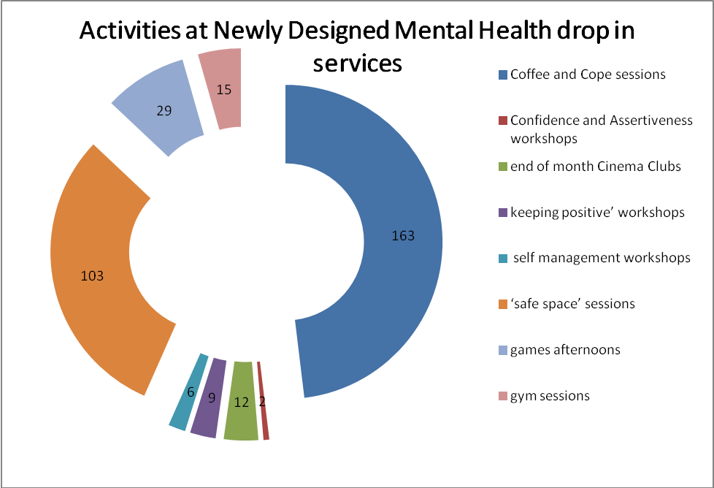
People with serious mental health conditions have greater control of their care and support through the implementation of personal budgets
The continued implementation of personal budgets has broadened to now include people with serious mental health conditions, resulting in more people remaining in their own home and receiving the support they need using flexible solutions. In 2012/13 86 people under the age of 65 with mental health conditions received personal budgets, of which 21 are Direct Payments. People use their personal budgets to meet the outcomes identified in their support plan using a variety of creative options such as learning life skills, specific therapies, taking a break and educational activities.
Carers are supported to maintain their health and well being, enabling them to continue in their caring role

Although there have been some budget reductions during the period, funding for all key services that support carers has been protected and some new services have been developed.
Carers have been supported through
- Access to employment through a job coaching programme
- Respite services that enable carers to have a break from their caring role; using a new service with 2 units at Fallings Heath
- A free emergency response scheme that provides replacement care and support services for individuals being cared for at times of a carer crisis
- Continued carer awareness raising, using the “Who Cares?” multi-media communications initiative. Walsall recently became the first council in the country to use Twitter to illustrate “a day in the life” of a carer. A Carers Rights Day event was held aimed at showcasing the range of advice and support available to carers in Walsall which was delivered in partnership with the local carers centre. The implementation of ‘Carer Aware’, which is a web-based toolkit that outlines carers’ issues, local support and carers’ rights.

Families and carers of people with serious mental health problems are being supported with their well being

A dedicated carer’s team operates within mental health services and continues to be successful in supporting carers and families of people with mental health problems. During 2011/12 and 2012/13 approximately 200 carers were supported each year. The team has been nominated for the second year for the Chairman’s award for services to the community. The team also provides support to carers of those with mental health problems through an informal carer’s course, Asian Women’s Group, Carers café and the Walsall Hub.

People suffering from depression and anxiety are being helped to improve their health, well being and independence through improved access to psychological therapies.

Since its introduction Walsall’s Improving Access to Psychological Therapies service has contributed to improved health and well being, with at least a half of those completing treatment moving to recovery and 90% experiencing a meaningful improvement in their condition resulting in less reliance on other mental health services. This has also helped improve their employment status and improved their social inclusion, helping them to retain employment or return to work, improve their vocational situation and participate in daily living activities.

People are supported by services that are better quality and have higher standards of care

This has been achieved by:

- Conducting a learning needs analysis across the whole social care workforce, including carers, PAs, those within the private, voluntary and independent sectors to inform a targeted learning and development programme designed to improve quality through raising staff skills and knowledge – resulting in the delivery of high quality care and support and people having real choice and control over their own lives
- Providing a learning and development programme designed to meet the needs of the whole of the social care workforce in Walsall which is resulting in a competent and skilled workforce capable of delivering the highest standards of care and support
- Launching a dedicated website in May 2012 to support the learning and development of the social care workforce in Walsall. This in resulting in the wider workforce having access to a range of learning opportunities and other information/support so that the skills and knowledge gained and maintained enables the delivery of high quality care and support
- Working with Health partners so that clinical skills training is included as part of the overall programme resulting in those in key roles, primarily within nursing and residential homes in Walsall, having access to training which enables low level nursing and preventative work such as continence management and falls prevention to be effectively managed negating the need for hospital admissions
Delaying and reducing the need for care and support

This will mean that

- You have the opportunity to have the best health and well being throughout your life, and can access support and information to manage your care needs. Earlier diagnosis, intervention and reablement means that you and your carers are less dependent on intensive services
- You can ensure that if you develop needs, the support you receive will take place in the most appropriate setting, and enable you to regain your independence.
Examples of what we have done to achieve this are:
Older people are being enabled to remain independent in their own home, through improved use of technology

The terms ‘Telecare’ and ‘Telehealth’ describe a range of technologies that enable people to maintain independence, health and well being and thus reduce the need for hospital admissions, or the need for adult social care services.

 | During 2011/12 adult social care has continued to focus on a linked programme of assistive technology known as ‘Telecare’ and ‘Telehealth’ as an integral part of health and social care services in Walsall.

Telecare
“I think Walsall Council is really looking after the elderly with this. I’ve got a wonderful family who visit me every day and help me but if I was to have a fall or anything I can’t get help quickly. I think it’s great and would tell other people my age to get them sorted out – it’s not costing me a penny.” [Alice – Service User]

In February 2012, as part of a plan to further keep older people safe and well, the council decided to make the basic telecare package (consisting of a pendant, key safe and smoke alarm) free for people who are aged 80 or over. A promotional campaign sought to ensure take-up amongst this group and ensure that everyone gets the equipment that they are entitled to.

July 2012 saw the introduction of an in-house team that are now responsible for all Telecare installations. This has increased service efficiency, and the team completed over 1,800 installations in the 9 months leading up to March 2013. The waiting time has now been lowered from 14 days to an average of 7 working days for basic installations and emergency installations are carried out within 24 hours.
24/7 response

During 2011/12 and 2012/13 adult social care introduced a 24 hours a day, 7 days a week response service so that people whose community alarm has been activated receive assistance as quickly as possible. The service is operated by reablement officers who are trained to assist people in emergency situations, for example if an older person has fallen over or fails to answer one of our check calls made by the Community Alarms service.

Adult social care emergency response officers aim to respond within 30 minutes of receiving a call and if appropriate call other emergency services such as the police for assistance.

Between January 2013 and March 2013 1,442 call outs were responded to by the 24/7 response service.

Working in partnership with the Community Alarm Service the response service now includes the installation of basic assistive technology in crisis situations reducing waiting times meaning people get support as soon as they need it .

Telehealth

Telehealth enhances the quality of life for patients with long-term conditions as it improves their health outcomes, sending alerts when they have an abnormal reading. Patients take their own vital signs using equipment and peripherals such as blood pressure monitors, scales and thermometers. This gives both patients and clinicians the early warning to take action and prevent further problems. It reduces the need for hospital admission or for going to Accident & Emergency.

It has been used in Walsall since 2008, primarily for Chronic Obstructive Pulmonary Disease (COPD) and heart failure patients. In 2011 Walsall Healthcare Trust and the council agreed to extend the collaborative use of Telehealth equipment to Walsall patients with long-term conditions such as heart failure and Diabetes, to increase the number of people benefiting.

Between April 2011 and March 2013 172 individuals benefited from a Telehealth package.
“I would 100% recommend Telehealth to anybody. I think that if everybody like me had a Telehealth monitor it would save so much expense in the long run and bring care into the home.”
“Telehealth gives me a sense of my own independence. I feel like I am not on my own. I’m thrilled to bits with it.” [Emily – Service User]

People in need of care and support are gaining more control over their own conditions as experts, reducing the need for further care and support
Reablement is about giving adults and older people the opportunity and confidence to regain skills and independence they may have lost as a consequence of poor health, disability or impairment, or going into hospital or residential care.
During 2011/12 adult social care developed an in-house reablement service comprising of 70 officers, focusing on individuals’ needs, goals and outcomes and what the person wants out of life. Reablement includes helping people to become more independent with personal care tasks, support to become more mobile, equipment, and help to find social activities in the community. The reablement service works alongside Neighbourhood Community Officers (NCOs) who assist with lower level support and interact closely with individuals and/or families and carers to:
- Assist and advise on benefit entitlement, social activities and venues
- Arrange small packages of support
- Undertake a high number of preventative referrals such as a recommendation to receive a Community Alarm

During 2012/13 the service joined together a number of health, hospital and social care services e.g. Occupational Therapists and Physiotherapists, to create a combined approach and speedier recovery period for the people after a stay in hospital or a period of crisis. These immediate interventions allow people to keep or re-gain their independence and to stay in their own homes and communities, preventing them from requiring more costly services or long term packages of support. It also provides an opportunity to carry out a more detailed assessment of a person’s abilities and needs so that the appropriate services and support will be available to meet their ongoing care needs if required.

The reablement service recently moved to a system of mobile working supported via the latest technology enabling the reablement staff and NCOs working alongside them to work at community locations as close as possible to the people they are supporting. Mobile working has also allowed the electronic transfer of information to other professionals as quickly as possible. The change from a walking service to a driving service, where appropriate, has enabled more people to be supported.
During 2012/13 the reablement service used internal support planners to assist with a speedy Personal Budget allocation and support plan creation. This proved successful in preventing delays by putting into place the appropriate support required as quickly as possible. In 2013/14 the service will explore the possibility of social care facilitators undertaking this support planning role.
Between January and March 2013 the reablement service received 466 referrals. Of these 178 were supported through a full reablement programme.

Hospital patients are now more involved in decisions related to their discharge planning arrangements, enabling them to be discharged from hospital as soon as practically possible with a range of interventions that will increase their independence, health and well being
Walsall’s integrated hospital discharge service allows patients and their families to influence decisions and make informed choices on the options available to them on after discharge from Hospital. This enables people to return home as soon as possible with appropriate interventions, support from within the community and the use of a range of assistive technology solutions.

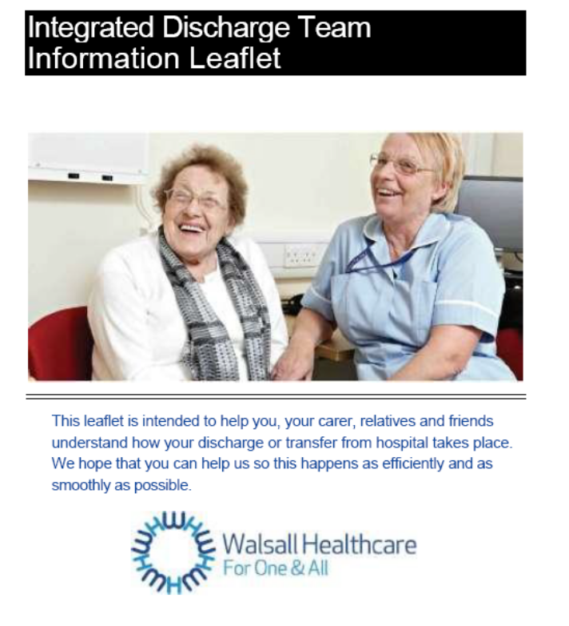 | The service actively engages with patients and their carers during the discharge planning process by offering information, advice and guidance on the options available to them to provide the best possible outcomes after discharge.  During 2011-13 the service has reviewed and redesigned how it provides information. A new Integrated Discharge Team leaflet is now available for patients and informal carers upon request, outlining what the Integrated Discharge team offers and what patients should expect if they are admitted to the Manor Hospital and are supported by this team. By changing the ways of working, the number of times patients and their families are asked the same questions, which is something which people find stressful and frustrating is being reduced.

By working with the intermediate support service, community reablement service and housing partners the discharge service is ensuring that the identified essential support is in place in readiness for the persons planned discharge, reducing their length of stay in hospital where possible. The priority of the service is to continue to provide support to people in the community and in their own homes, making recommendations for admittance to permanent residential and nursing home placements only when absolutely necessary.

Since December 2012 through the use of Walsall Council’s Aids and Adaptations Framework, work has been undertaken in partnership with Walsall’s Manor Hospital to deliver high priority minor works direct for in-patients to assist with timely and safe discharge to their homes. This expands upon the highly successful Handyperson Scheme available to those over aged over 55 in Walsall.

People are being helped to maintain their independence and reduce social isolation through a range of community based initiatives

Now, more than ever, there is a focus on people getting support in their community rather than from adult social care and on people finding local solutions to local issues. Adult social care is continuously working with voluntary and community groups to reduce reliance on social care support.
Community social work focuses predominantly on working with those people who are not eligible for social care services. The purpose of the community social work team is to build up people’s resilience and independence and to reduce isolation by working closely with the individual and their family. Social workers liaise with relevant agencies to identify cost effective and sustainable solutions, including social housing providers, the Welfare Rights Service and Neighbourhood Community Officers, as well as using local specialist community resources where needed for example to support people with substance misuse issues. Social workers also support over 30 voluntary and community groups with funding bids, advice, and the identification of unmet need within areas of the borough.
An example of community social work was the need to ensure an adequate housing environment for a group of 3 adults with a mild learning disability. Help was sought from the local Area Partnership, community and voluntary organisations, fire service, faith organisations, charities and neighbours to obtain furniture (including delivery, transport and installation) at no cost to the council.

By building up a network of contacts within the local community, social workers routinely become aware of groups and individuals who are prepared to offer their services to those people who need help within their community e.g. a group that collects and distributes unwanted tins of paint, volunteers to provide transport in a crisis, as well as identifying grants and community funding for furniture, food and clothing.
The council is helping people develop small organisations to support people in their local community. These services can be bought both by those who fund their own care and by those who have a Personal Budget. They can also be bought by Walsall Council or the health service. 13 of these organisations (known as micro-enterprises) were identified or established within Walsall during 2011/12.
Another example of a community based initiative is the Taste for Life service which promotes the availability of a variety of meal provision across the borough, providing support and access to services that are focused on individual needs and aspirations. The service has extended its community based brokering facility to include support with shopping and/or cooking, lunch club attendance and signposting and supporting access to direct meals provision, all reducing reliance on social care services and addressing issues of social isolation.

People with care and support needs are receiving the relevant financial benefits they are entitled to and are maintaining their financial independence

 | Adult social care has responded to an increased demand for financial support and advice by creating 2 financial advisor posts within the Welfare Rights Service during 2011/12. These advisors help people manage their personal finances.  The main activity of the Welfare Rights Service relates to claims for Attendance Allowance, Disability Living Allowance, and Carers Premium, as well as Council Tax Benefit and Housing Benefit.  The Welfare Rights Service is available to all Walsall people, including those receiving social care services.

During 2011-13:

- 3568 financial assessments were carried out
- 900 benefit checks were undertaken
- £21.3m additional money was gained for residents across the borough through benefits maximisation
- 635 benefit awareness sessions were held at venues across the borough (including Benefits Based Charging consultations)

Specifically in 2012/13

- 379 benefit reviews were undertaken for the reablement service
- 115 benefit maximizations were carried out for family members on visits

People with mobility problems are being supported to live independently in their own home

Walsall’s initiatives to help people with mobility problems live more independently are

- An Independent Living Centre
- Investment in aids and adaptations
- New housing developments
- An Integrated community equipment services

Independent Living Centre

 | The previous Centre for Independent Living was primarily an information and advice point for people who needed help and care, but it did not offer the on-site help and support, facilities or other services that adult social care wanted to provide. The new Independent Living Centre is the first point of help and advice for those wanting to live independently in their own home

The re-modelled Independent Living Centre (ILC) opened in 2012 and offers:

- Tailored advice and support from 4 independent living advisors
- Advice and information from the Occupational Therapy service regarding all aspects of daily living, from simple gadgets available through to the latest technology. This is a drop in service from Monday to Saturday with no appointment necessary. People are encouraged to test equipment they may find useful, for example I-Pads. Close links with the council’s Housing Standards and Improvement Team has meant that referrals for items such as stair lifts and low or level access showers can be made direct from the ILC with no further assessment being required, helping people get support as quickly as possible.
- The latest Telecare and Telehealth equipment so that people can see the whole range of what is available and get information on where to purchase it
- Mobility assessments for the provision of Blue Badge parking permits. This has resulted in a reduction in waiting times and means that people attending for assessment are able to discuss and resolve other disability issues at the same time.
- Advice to people with hearing and/or visual impairments via a sensory support drop in service. A wide range of sensory equipment is available at the centre for demonstration.
- Other initiatives including hosting a dementia café, working with Brownie groups and school children to raise disability awareness amongst the wider community.
During its first year over 4,000 people accessed the new ILC for information, advice, assessment and equipment provision.
As part of a ‘one stop shop’ approach adult social care also relocated the ShopMobility service and short term wheelchair loan service to the ILC.

- ShopMobility is increasing in popularity with almost 2,000 hires being made in the first 12 months.
- Short term wheelchair loans have also become well established at the centre with approximately 500 loans completed to date

Aids and Adaptations and Disabled Facilities investment

Working with other council colleagues, major improvements have been made in providing timely and appropriate adaptations (where equipment alone cannot meet a person’s needs). Between 1 April 2011 and 31 March 2013 596 major adaptations were delivered at an average cost of £7,391. This means 21% more adaptations and a reduction of over one third in their average cost.

Through major streamlining and service improvements, the waiting list for Disabled Facility Grants (DFGs) has reduced from 551 in March 2010 to 130 in March 2013. As well as tackling the waiting list the time that households have to wait has dropped significantly from referral to approval for a statutory Disabled Facility Grant (DFG) from 27 weeks at end of March 2011 to 7 weeks at the end of March 2013.

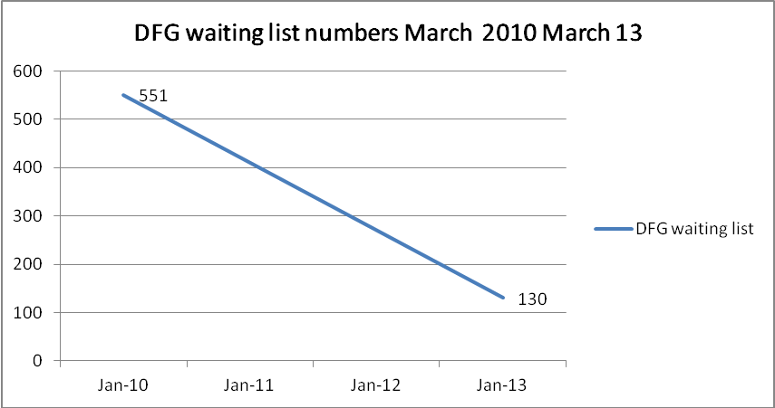

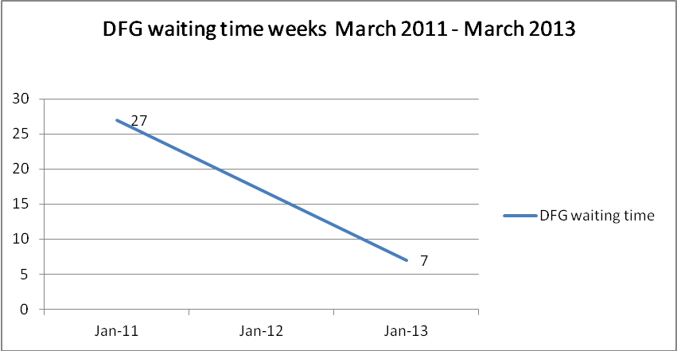

Through the use of land charges on the more expensive DFGs since 2011, in line with government policy, adult social care has already recovered and been able to re-invest over £107,000 into new adaptations.

In 2012 a new Contract Framework for the West Midlands was developed for the installation of lifts and hoists that is leading to 39% cost savings meaning more help can be offered with the same level of funding with the continuation of free maintenance and servicing works for households.

Through major streamlining of the statutory DFG process and use of discretionary funding from the council under the Aids and Adaptations budget, support for the provision of adaptations for people assisted by NHS Palliative Occupational Therapists is prioritised to ensure timely and relevant provision of works to meet the household’s needs.

Other initiatives since 2011 include:

- Preventative Adaptations Assistance to help those households who do not meet the statutory DFG criteria with the cost of adaptations. This service has helped 65 households through providing land charged ‘grants’ for adaptations.
- Supporting Independence – a project with the flexibility to improve both corporate and community run buildings to provide local community ‘hubs’. In 2012 the new Mencap Town Centre Hub was completed creating the second registered ‘Changing Places’ facility in the borough.
- Work at Holly Bank House has continued to provide a 21-bed reablement centre.

Housing investment

Through negotiation with social housing providers between 2011 and 2013 12 new adapted homes have been created in the borough including properties at the new Waterfront development in Walsall town centre.

Between 2012 and 2013 new disabled accessible units have been developed at the council’s housing projects (Dolphin House and Green Lane) which provide temporary and emergency accommodation for households faced with homelessness.

Improvements to the Integrated Community Equipment Services (ICES)

Adults, children, families and carers are benefiting from a purpose built centralised equipment service that provides greater accessibility to a wide range of equipment for both children and adults, responding effectively to the increased demands for equipment for daily living.

The newly built service has increased accessibility to the service, with an improved wheelchair assessment area, and space for the decontamination and recycling of equipment, making it even more efficient. Over 90% of equipment is recycled and used again.

The co-location of equipment for both children and adults are making the provision of equipment easier and more straight forward for children, young adults, families and carers. This helps people particularly during the transition between children’s and adults services meaning they have a single point of contact for all their equipment related needs.

Vulnerable households are being supported to tackle fuel poverty and remain warm

Experiencing cold within the home is a key contributory cause of illness (mental and physical) and excess seasonal deaths.

Walsall Council, together with Walsall AgeUK, have targeted support to vulnerable households in the borough to tackle excess cold and fuel poverty (defined by the Warm Homes and Energy Conservation Act 2000 as a household that is living on a lower income in a home which cannot be kept warm at a reasonable cost). Work has included:

- 18,000 homes made more energy efficient, addressing fuel poverty through the delivery of Community Energy Saving Project and securing Carbon Emissions Reduction Target funding which has attracted investment of £30m
- Maximising investment from Energy Company Obligations and other forms of Green Deal to help residents fund home insulation and heating improvements
- Providing a grant and advice service (Health Through Warmth) and a funding safety-net for the most vulnerable households to help pay for essential heating and insulation works
Ensuring that people have a positive experience of care

This will mean that

- You will be satisfied with your experience of care and support services
- You will be respected as equal partners throughout the care process, including carers
- You will be aware of what choices are available to you locally, what you are entitled to, and who to contact if you need help
- You will be involved in making decisions on social care, and social care will maintain your dignity and ensure support is sensitive to your circumstances
Examples of what we have done to achieve this are:
People with multiple disabilities are supported to reduce social isolation and increase their independence, by being provided with friendship and stability
In 2010/11 adult social care said that people with disabilities would work together with older people, people using Mencap services and Goscote area residents to develop a community farm.
Since 2011/12 the creation of a partnership to invest in, direct and develop the capability and capacity of the former Goscote Lane Adult Training Centre site into a community resource centre has been delivering a broad range of services and facilities to meet the needs of the local community.
The site has been fully refurbished and sets a high standard of provision to ensure that dignity of users is preserved, accessibility of services is optimised and the physical provision of care is undertaken in a safe, clean and positive environment. The facilities developed there meet and exceed legislative requirements and provide a model resource the community can be proud of.
 | Goscote Greenacres is managed by a community management group and 30 local residents have been allocated plots on the site. The Recruitability Scheme also operates at the site, with 4 people with learning disabilities being employed to assist with the growing fruit and vegetables. Fishing rights for the local canal have now been granted, with a disabled fishing platform for people with wheelchairs to ensure full access.
It has a wide range of environments enabling personal safety to be managed effectively and providing opportunities to experience new activities that would normally be either be higher risk or not available, including personal therapies, and working on allotments. As a result, people are complementing and reducing their support needs through these developments.
“When I visited [Goscote] I was struck by how much of an asset it is to the centre’s users who are so proud of the scheme as well as the community who are also reaping the benefits“[Councillor Barbara McCracken]

The quality of life, health and well being and independence for people with learning disabilities and mental health issues is being increased by providing homes which they can call their own

Adult social care has developed a range of supported living schemes where people can live as independently as possible  Our care and housing reprovision programme for people with learning disabilities and mental health needs has moved people from residential care settings back into their local communities, primarily within supported living environments. | 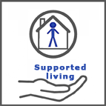

During 2012/13 adult social care committed to continuing to relocate people back into their local community from residential placements, both outside of Walsall and locally. The council believes that this is the right thing to do to enable people to maximise their dignity, choice, respect and independence.

By working closely with individuals and their families, 44 people with learning disabilities either moved into their own home, into a supported living establishment, or into an Extra Care housing scheme. Of those, 44 people relocated back into Walsall, 9 were from residential care homes outside of Walsall

The focus on supported living and care in the community is also evidenced by the number of people with learning disabilities in residential care reducing from 191 at 1 April 2011 to 126 at 31 March 2013.

Adult social care is continuing to work with local housing and support providers to develop and provide a wide range of housing and support options in Walsall.

Mental health supported living programme:

During 2011/12 and 2012/13 20 people were moved from residential care into supported living accommodation following the development of recovery pathways, whilst 2 people moved out of residential care and are now living independently .
Carers of people with learning disabilities with complex/challenging behaviours are benefiting from respite services that are alleviating stress and anxiety and contributing to improved health and well being
Carers for people with learning disabilities across Walsall identified the need for adult social care to support them in their caring role as one of their highest priorities.

As a result, adult social care has redesigned its respite services for people with learning disabilities at Fallings Heath. This has provided 8 beds for people with complex, physical, sensory and learning disabilities and an additional 5 units for complex and challenging behaviours.

The respite service offers support for carers to allow them to access appropriate short breaks and enable them to continue as informal carers, potentially reducing the number of admissions to permanent residential and nursing care establishments if carers cannot cope.

It offers individually tailored packages of support based on people’s individual choices. Whilst using this service, people are assisted with their daily living skills to help them to become more independent. These services have been designed to take into account the needs of people with autism.

People’s experiences of care and support is improving through supporting services to provide high quality care

A quality assurance team was established within adult social care in 2012 to monitor quality and raise standards within care homes and other care providers in Walsall. Working with Health and Social Care partners and the Care Quality Commission (CQC), the service aims to deliver outcomes that give people in receipt of care services the protection, dignity, respect, quality of life and choices to which they are entitled and expect to receive.

This has been done through

- Quality improvement audits - to ensure people can expect consistently good quality residential and nursing care across the care market, quality assurance improvement audits have been undertaken with care home managers of the majority of Walsall’s 65 care homes, focusing on all aspects of good practice and identifying areas for improvement.
- Self assessment questionnaires - to ensure that all agencies regulating and monitoring care homes co-ordinate their activities quality assurance processes for care homes have been simplified into a single self assessment questionnaire. 55 care homes have completed the assessments enabling quality comparisons across the borough and the area.
- A Care Home Visitors Scheme - whilst there are extensive formal arrangements to monitor concerns and complaints, the “Hearing the Voice of the User” initiative examined the opportunities that care home residents have to speak about their circumstances. As a result, opportunities were developed for residents to have informal regular contact with an independent visitor and a Care Homes Visitors scheme was launched in January 2013. The scheme led by the Vine Trust will arrange regular volunteer visitors to targeted care homes.
- A Leadership development programme - it is essential to support existing managers and develop the care managers of the future. A Registered Care Managers leadership development programme was established with Health partners to support managers in the 13 Nursing care homes and a further 15 places for residential care home managers. Participants have an opportunity to design a project that directly improves their care homes.
- Care provider forums - to ensure developments in care that directly benefit the service users are captured, it is important that there is clear communication with care providers. A range of improvements in multi-agency local care provider forums have taken place including specific workshops with care homes (55 attending or contributing) and Support to Live at Home Services (120 attending).

- An incentive scheme - care homes were involved in developing an Incentive scheme that provides financial support for initiatives that will improve care quality and facilities and benefit service users. Awards have been made to develop Pelsall Hall’s community gardens, Oak Lodge’s sensory garden and Homestead residents’ sensory room. Residents’ views are central to approval of applications and ensuring that outcomes are achieved.
- Embedding quality assurance - to ensure services are of a high quality, the contracts and service specifications have to be designed to scrutinise all potential care providers to ensure they are capable of delivering services to the required standard. Work was undertaken with joint commissioners to embed quality assurance within contract frameworks and tenders (e.g. carers support and emergency discharge tenders).
- Dignity in Care initiatives - care recipients experience their care through their relationships with care staff. At the heart of good care are values such as patience, kindness, understanding, and respect that ensure dignity. A council-wide initiative to support the national Dignity in Care goals was co-ordinated and included the council’s sign up to the Dignity in Care Pledge. Two major workshops were held (attended by 200 staff and 85 care provider organisations) with information and advice to support staff and managers to become Dignity in Care champions.

There were also a series of significant health initiatives to raise the quality of nursing care, reduce severity and incidence of pressure ulcers, improve medicine management and infection control including:

- A time limited Medical Review Team, consisting of a GP, Pharmacist and specialist nurse/health professional, to provide improved clinical support and training for care homes
- Improvements in nursing home awareness, training and communication on clinical protocols and hospital discharge arrangements
- Reductions in inappropriate referrals and admissions to hospital where care can be best provided in the care home.
Safeguarding adults whose circumstances make them vulnerable and protecting from avoidable harm

This will mean that

- You will feel safe and secure
- You will be free from physical and emotional abuse, harassment, neglect and self harm
- You will be protected from avoidable harm, diseases and injuries as far as possible
- You will be supported to plan ahead and have the freedom to manage risks the way you wish
Examples of what we have done to achieve this are:
During 2012/13 the adult safeguarding unit undertook 35 complex/large scale investigations where there were concerns about residential/nursing or home care provision involving several residents. These investigations involved close working with key partners such as health and police, along with other teams from the local authority such as quality assurance and contract monitoring. In 18 of these cases, concerns were investigated and resolved within 4 weeks. The remaining 17 were investigated and resolved over a longer period.
Investigations into safeguarding concerns make vulnerable adults safer by:
- Requirements for services to undertake specific improvements
- Advice and support with further training for staff
- Action against individual staff
- Suspension of admissions until improvements are completed
The adult safeguarding unit has also co-worked or supported teams throughout adult social care with individual safeguarding investigations and case conferences.
Adult social care has continued to raise awareness of the safeguarding adults’ agenda among vulnerable groups and the general public. Over 140 presentations have been given to a various community organisations and care providers. Over 25,000 leaflets, posters and information cards giving information about how to recognise harm and abuse and how to seek help have been distributed to the public.
The West Midlands Multi - Agency Safeguarding Adults Procedures have been adopted by the adult safeguarding partnership board and are now in use across all agencies. The procedures are on the board’s website, along with local guidance to support their use. Briefing sessions have been provided to adult social care staff. These regional procedures mean that people will receive a consistent response from all agencies no matter where they are in the region.
A clear set of safeguarding intervention thresholds have been introduced in order to provide guidance about the concerns that need to be dealt with as ‘safeguarding' and those that can be managed in other ways. This helps to ensure that resources are being used where they are most needed.
A positive approach to risk taking and the development of personalisation contribute to people having control and choice over their lives. People who are empowered and able to increase their confidence in making decisions to take control are less likely to be at risk of harm and abuse.
Work is under way to ensure that timescales are met for undertaking safeguarding investigations. All decisions about whether to progress a safeguarding referral have to be taken within 24 hours of receiving the alert. An initial investigation must be completed within 5 days and a full investigation undertaken within 28 days. Following these timescales means that people’s safety can be ensured speedily and they are not subject to lengthy delays with uncertainty and worries.
Additionally, this year, adult safeguarding has taken responsibility for work related to the Mental Capacity Act 2005. The Act provides a framework for acting and taking decisions on behalf of people who lack capacity to make decisions for themselves. This work includes the Deprivation of Liberty Safeguards which is designed to protect the interests of very vulnerable people who, in their own best interests, need to be accommodated in care or treatment settings but lack the capacity to consent. Assessments are undertaken by trained Best Interest Assessors to promote vulnerable people’s safety and well being and protect against possible exploitation and harm.
Partnership working
Regular weekly information sharing meetings are held with representatives from quality assurance, contract monitoring, reviewing and the hospital. These meetings have helped to ensure that concerns about care provision are highlighted and information shared so that early intervention can take place where there are risks to vulnerable adults.
The development of a Black Country Vulnerable Adults Hub by West Midlands Police has promoted closer and more effective working with police. This is a recent development but early feedback is positive.
A flagging system has been developed with the Manor Hospital, so that clinical staff will be alerted on admission, or visit, to A&E when vulnerable adults are subject to safeguarding concerns.
During 2012/13 adult safeguarding has included close working with Domestic Abuse services and in now actively involved in both Multi-Agency Risk Assessment Conference (MARAC) and the Domestic Abuse Response Team (DART) processes. This involvement has promoted the recognition of the impact of domestic abuse for vulnerable adults. There has traditionally been a low level of recognition, particularly for older people.
Walsall Adult Safeguarding Partnership Board
The board oversees the co-ordination of effective safeguarding for adults who are at risk of harm. It carries out these responsibilities largely through the work of sub groups where clear objectives and work plans have been set including:
- Communication sub-group: A key role is awareness raising for the general public; this has directed the work of the adult safeguarding unit in campaigns, presentations and events. There is a website that now provides easier access to information about the work of the Board, guidance in relation to procedures, information about events and the work of partner agencies throughout Walsall. The Board also produces a newsletter which is widely circulated throughout partner organisations and voluntary and community organisations.
- Quality sub-group: a quality framework has been developed and case audits are being undertaken in order to identify areas of learning that can be shared. A regional approach to quality and performance has been agreed with other Black Country authorities and a regional sub group is being piloted to support the ability to share learning on a wider basis.
- Training sub group: 159 staff have attended training ranging from safeguarding awareness to handling evidence. The training delivered by all partners has been mapped to identify opportunities for sharing/joint training. Consideration is currently being given to the modes of learning that can be developed to raise participation in training.

Older people are being provided with a secure and safe environment as an alternative to residential care

Adult social care has been working with our strategic housing partners including Housing21, Accord Housing and Midland Heart, to re-model our extra care housing support as an alternative to residential and nursing care. This has included integrating community facilities into the schemes.

Extra Care housing offers a purpose built enabling environment that minimises risk and overcomes barriers found in unsuitable housing where frail elderly people are unable to negotiate stairs to access bedrooms and bathrooms. Telecare and telehealth networks supplement a range of monitoring and support services within the schemes that minimise the need for direct intervention from paid carers.

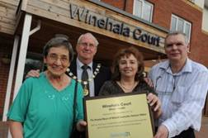 | Adult social care has spent £5.368m and £5.969m in 2011/12 and 2012/13 respectively, to enable people to have their own home and remain independent in a safe and secure environment, accessing support as and when they need it.  During 2012/13 379 people accessed Extra Care Housing schemes in Walsall.

Vulnerable adults are being enabled to live independently in their own homes and share their talents with others through networks of support

KeyRing is a support organisation that is based around people living in their own homes and sharing their skills and talents with each other and with their communities. There are a number of supported living networks, which are made up of 10 ordinary homes. People who need support (members) live in 9 of them, with a Community Living Volunteer living in the 10th home. Volunteers are supported by Community Support Workers and Supported Living Managers to enable members to link into community activities and services.
KeyRing are currently working in partnership with Walsall Adult Community College to allow members access to a cooking and life skills course. They also run a Community Connections Club at Manor Farm Community Association and a member-led bowling club at Bloxwich Bowling Alley.

“I moved into my new flat last year and its good that I could choose my carpets and wallpaper for myself. “ [Stuart – Service User]

“While he [Stuart] has had difficulties in the past, because of his condition, he is now going from strength to strength and is a good example for other people to see what can be achieved.” [Amanda Benton, Social Worker]

From 1 April 2011 to 31 March 2013 the number of networks increased from 2 to 9, increasing the number of people supported during this period from 16 to 90. KeyRing have released savings for social care and the health service by, for example, supporting:

- 3 people to move out of a secure unit and live independently in the community
- 1 young person to live independently with a move back to Walsall following the end of a residential course
- 6 people to live independently following their move out of residential care

The lives of people with dementia are being enhanced through a number of initiatives in Walsall

During 2011/12 adult social care established new services under a Joint dementia strategy ‘Living with Dementia in Walsall’ to support people with dementia and those who care for them:

- Dementia Support Workers are based in the Manor Hospital to prompt best practice in dementia care through a new integrated dementia pathway
- Dementia Cafés which work to an established evidenced based model to reduce crises and provide ongoing support from other carers, health and social care professionals, and the café organisers. Dementia Advisors are based at the AgeUK office in Walsall, with a dedicated telephone line to provide support to people with dementia, their carers and staff working in dementia care
- A training programme was implemented so that social care staff can identify people with dementia much earlier, provide appropriate information and support for individuals to help themselves and access non-statutory services for as long as possible, delaying the need for formal care and support.
- Adult social care has been raising awareness of dementia and its effect on people’s lives, in order to reduce stigma and increase engagement with services
- A scheme which supports care homes to improve the quality of care for people with dementia which includes things like creating dementia friendly gardens and increasing physical activity within homes, has been introduced

During 2012/13 adult social care continued to develop services for people with dementia by:

- Commissioning a number of dementia support workers to raise awareness of dementia and promote healthy lifestyles in hard to reach groups such as the sensory impaired and people from black and minority ethnic groups. A support worker is also based with the Memory Service visiting people after diagnosis to offer support, information and signposting.
- As part of the response to the Prime Minister’s challenges in dementia, commissioning 400 hours of development work from two experienced providers of dementia care and dementia training to go into Walsall businesses to support them and to make Walsall a more dementia friendly borough. Local service users and their carers chose the logo for a Kitemark award, identified which businesses to work with first, and will become mystery shoppers to monitor the on-going quality of this work.
- Improving understanding in dementia, older people’s mental health, healthy lifestyles and behavioural and psychological symptoms of dementia four next-stage through the development of training modules with council and clinical staff from learning disabilities, mental health and the acute hospital. Whilst the modules have been developed for council, acute hospital and mental health staff, other providers are encouraged to fill empty places free of charge.
- Encouraging more therapeutic activity in care homes 20 iPads with dementia applications, 5 Rempods (reminiscence therapy portable rooms) and ten reminiscence boxes have been purchased to loan out free of charge to care homes and community groups.
- Developing a new integrated dementia pathway through a steering group with staff from all disciplines at the hospital, and which was shortlisted for an award and cited as good practice by the Strategic Health Authority.
CONSULTATION ACTIVITY

Adult social care is committed to involving local people in making decisions about services.  The council believes that being involved in decisions about health and social care is a right, not a privilege for people. | 
Adult social care listens to what people say to us; use this information to improve health and social care services in Walsall, and feedback regularly on how comments have helped to improve services. Examples of this are:
- Readers Group: this is a group of service users and carers who review our public information before it is printed or published on the web to ensure the format is suitable for the audience, the language is clear and the purpose is easy to understand. The group includes older people, people with learning disabilities, physical disabilities or mental health issues, and carers.
- User/Carer Reference Group: this was set up to inform and involve people in the development of personalisation in Walsall, by influencing many social care developments. The group includes users, carers, and representatives from a range of voluntary sector and community organisations.
- Over 50s Forum: this is an independent group consisting of volunteers working in partnership with local and national government departments, and local council and voluntary groups, to improve the quality of public services and assist with the introduction of new services to improve the lives of people over 50. Anyone can attend their open forum meetings.
- The Carer User Support Partnership Group: made up of people who are carers or users of services. Providers also sit on the group as representatives. Feedback is used to influence decisions made about future adult health and social care services.
- Walsall Partnership Quality Board: this is a multi-agency board that aims to enhance the quality of life for people with care and support needs, ensuring that they have a positive experience of care and support. Service user and carer representatives, including Health Watch, are permanent members of the board. “Hearing the Voice of the User” sub-group, with service user and carer involvement, has led to the establishment of a community based care home visitor scheme, run by volunteers.

During 2011/12 and 2012/13 adult social care has undertaken a number of consultation exercises on specific events and services to help us decide what the service should look like in the future. Feedback from consultation is helping us decide on our priorities for future years. Examples are:

- Summer Scheme: This is run annually as a preventative service providing respite to families and carers through activities for people with a learning disability during the summer break when schools/colleges are closed for up to 10 weeks leaving many with no alternative provision and family/carers with no or limited respite provision. At the end of the scheme, an evaluation form is completed by service users, carers and volunteers to feed back about their experience and how adult social care can improve the service. This information is then used to inform scheme users on how Social care plan to use it to help shape the service.
- Carers Strategy: through a number of consultation events, carers were asked to tell us what social care did well to support them, what social care needed to improve, and to share their experiences on being a carer. A strategy was developed from this feedback and sets out what carers have told us is important to them, with a commitment from the council and partner agencies to deliver the required change. The strategy was launched in 2012.
- Broadway North Centre: consultation and briefing sessions were undertaken at several venues within the borough with staff groups, service users, and others to discuss the mental health services currently offered at the centre, how well these are working and about the future of the centre. Social care are using this feedback to help us plan what the centre could look like in the future to support individually tailored support plans based on the community model.
- Community Alarms Service: a survey has been carried out with a sample of 250 Community Alarms Service users. Social care asked them various questions about the service including speed of response, the helpfulness of the operators and the service in general, value for money, and how they would like their opinions on the service to be gathered in the future. Feedback received from this and future surveys will be used to continue to develop and improve the service.
- Links to Work (LTW): during 2011/12 social care consulted with service users and carers, LTW staff, senior management and local businesses that contract with LTW. Social care asked them whether they were aware of the services offered and the effectiveness of these services. The feedback from this consultation will help us to plan our future priorities as part of our employment strategy.
- Support to Live at Home: specific consultation has been undertaken through workshops for Support to Live at Home providers, care homes and specialist providers culminating in two major events to promote Dignity in Care in February 2013.

Learning from complaints

It is crucial that complaints are used to help the council and its services to improve service arrangement and provision. People making a complaint want to know that the council has learned from its mistakes – and it is important that those mistakes are not repeated.
All complaints about our services tell us something, even when the council has not necessarily made a mistake or got something wrong. They provide information about our services, about our customers, about customer perception of our services, and about customer expectations of our services.
Learning during 2011/12 and 2012/13 has resulted in improved staff performance through training and supervision, and there are other recommendations that could lead to improvements for service users. Examples are, that as a result of a complaint:
- A system has been implemented where carers can confirm arrangements up to 6 weeks before respite is required
- The criteria for the provision of a level access showers are being reviewed to ensure that they truly promote independence
- A major review of the processes for all Disabled Facilities Grants was undertaken and new streamlined systems were developed to reduce the length of time taken from referral to formal consideration of a statutory DFG.

 | OUR PRIORITIES FOR 2013/14

Walsall Council believes that the progress made during 2011/12 and 2012/13 places us in a good position to respond to the demographic and financial challenges that it faces. The strategic direction set by the government is clearly set towards prevention, recovery and rehabilitation with a move to increasing the personalisation of services and working in collaboration with partners and the local community to achieve improved outcomes for users of our services.

Council-wide priorities for 2012-16 are to ‘Make Walsall a better place to live, work and invest’ across 3 key areas:

- Health and Well Being
- The Economy
- Communities and Neighbourhoods.

As a result, our priorities for 2013/14 are:

Enhancing the quality of life for people with care and support needs

Continue to support carers to maintain their health and well being, enabling them to continue in their caring role

In 2013/14 our priorities for carers are to
- Establish a carers partnership board to monitor the monitor the implementation of the carers strategy, discuss and address common areas of concern, raise awareness and improve understanding of the role carers play in supporting other people and exchange ideas and share examples of good practice in developing support and services so carers can remain in their caring role for longer
- Implement the Triangle of care model within mental health services which is a partnership between the people experiencing mental health issues, the staff member and carer that promotes safety supports recovery and sustains wellbeing
- Strengthen family and carer engagement
- Establish a carers mental health and well being service
The learning needs analysis undertaken by workforce development will be used to develop a “Confident to Care” programme, comprising a range of flexible, bite-sized workshops supporting carers to look after their own health and well-being.

Increase employment opportunities

Adult social care will increase the numbers of people with disabilities in paid employment, particularly focusing on people with learning disabilities and mental health issues.

Increase housing choices

Adult social care will work with housing partners to develop local accommodation that meet the needs of service users and vulnerable adults. This will include finding mortgages for people with disabilities and an adapted housing register for people with learning disabilities to help us match accommodation to people needs

Continue to develop personalised services

Adult social care will

- Ensure that each people user who receives a Personal Budget receives the support of an agency of their choice to help them plan their care and support
- Ensure that when service users design their own support with our help they place sufficient emphasis on leisure activity and employment where appropriate
- Work closely with children’s services to ensure that when service users requiring our support reach adulthood they can choose support to meet their needs
- Continue the development of our advocacy services to ensure that service users who cannot speak for themselves are represented and supported

Delaying and reducing the need for care and support

Continue to develop the Independent Living Centre

This will be achieved through greater engagement with Walsall NHS and looking at how the centre can link in with other services to enable people to have assessments, ordering and fitting of equipment all done from one central point.

Continue to develop the Integrated Community Equipment Service

The Integrated Community Equipment Service is currently looking at improving its IT system in relation to ordering and financial systems. The streamlining of IT systems will improve the service’s ability to operate more closely with key partners such as the Independent Living Centre and Links to Work, linking the assessment, ordering process, financial management, and scheduling of the delivery and/or fit of equipment. It will also allow monitoring of equipment to highlight when a review is required to meet statutory health and safety requirements such as the Lifting Operations and Lifting Equipment Regulations (LOLER).

There is scope to further enhance the service by using the new base to incorporate Telecare and Telehealth equipment into one location allowing for a more streamlined response and effective service.

Review our Community Bases

Following consultation exercises social care will review and re-model our community bases (day care provision) to focus on what people enjoy doing and what will achieve the best outcomes for them. This will include expanding the variety of activities available, such as cooking, fitness classes, dancing, computer skills, sewing, and sports.

Continue to develop ways in which people can help themselves

Adult social care will

- Provide clear, simple guidance to people so they know how to access services suitable for their needs and what to expect
- Continue the development of the Community Social Work model within our six partnership areas and link with voluntary sector and community groups to create self sustaining initiatives helping improve quality of life. Our developments will focus on addressing people different cultural needs and extend the range of services and options to people across local areas helping people to sustain independence, within their own community
- Work with housing partners to provide aids and adaptations within people homes for those who need them
- will increase our investment in technology to help people remain in their own homes and prevent service users from needing long term care and support

- Work with strategic housing partners to redesign Extra Care services, providing a greater focus on local facilities within the community for use by the general population
- Re-model its Neighbourhood Community Officer service to provide simple financial advice and support (for example how to access welfare benefits)
Continue to develop the reablement service

During 2013/14 work will continue to develop the reablement service by expanding on the achievements made during 2011-13:
- Capturing service user outcomes to inform and improve business processes and to identify and plug any gaps in service to provide an effective reablement service to people in their time of need :
  - Information is captured throughout the reablement process from start to finish of an individual’s programme, including effectiveness of the programme and whether the same level of independence is maintained by an individual after the end of the programme.
  - Business processes and paperwork was re-designed during 2012/13 and will be implemented during 2013/14 to focus on individual outcomes
- Completing the service restructure to ensure it can be as flexible as possible through a workforce with the appropriate skills and knowledge to effectively meet people’s needs
  - Work continues to ensure that staff are equipped with the necessary knowledge, experience and skills to work within and support the development of community reablement.
  - A fully resourced, re-structured and multi-skilled workforce will ensure that the service can effectively meet the increased demand for reablement services
- Preventative reablement by enabling people to access community services
  - The Neighbourhood Community Officer Service works with individuals to gather information to enable them to access local services and activities that will help them maintain independence following a reablement programme.
- Continuing to work with Health and internal partners to develop a multi-disciplinary approach that eliminates gaps in a reablement programme, reducing the need for further ongoing support once a programme ends
  - Re-structuring of the service and continued partnership working with Health and internal partners will create an integrated front end service that links to hospital discharge and bed based services to effectively re-able an individual back into the community
- Development and review of ICT systems to increase mobile working and officer time in the community to support and monitor people through their reablement programme
  - A large scale upgrade of ICT systems is to take place to provide back office functions that will lessen the time officers spend on administration, increasing activity within the community and provide a speedier response to individuals to progress their independence or provide additional support where increased needs are identified.

Continue to develop the Frail Elderly Pathway

Work will continue to develop the Frail Elderly Pathway to provide care in a person's own home to reduce the unnecessary use of acute hospital beds and care home placements, thus achieving as good, or better, outcomes in a patients' health, well-being and quality of life.
This will focus on the continuing development of multi-disciplinary teams which will include staff from primary care, social care, secondary care and the community sector, with single line management arrangements and shared accommodation.

Social workers, working alongside hospital staff within the accident and emergency department, will help prevent hospital admissions (where safe and appropriate) by using support in intermediate care or within people’s homes.

The aim will be to ensure that the need for ongoing social care support is determined within a 72 hour period after initial presentation at hospital

Work will continue on specialist preventative pathways (e.g. skin conditions) by working alongside community matrons to prevent people presenting at Accident and Emergency as a result of these conditions.
Ensuring that people have a positive experience of care

Re-model our in-house services at Broadway North Centre

The current model of mental health services at Broadway North dates back to 1994, and developments since that time in the form of implementation of the National Service Framework from 2001, and latterly personalisation of social care services, make these services out-dated and comparatively expensive.

A programme of re-commissioning of the services currently provided is under way to release resources from the historical pattern of accommodation based provision and focus on prevention and individually tailored support plans. The council will continue to work in partnership with the Dudley and Walsall Mental Health Trust to ensure that the re-commissioning of these services is fully incorporated into the overall service redesign for mental health services. Service users and carers will be consulted on any proposals for the development of services.

This model will help GPs refer to prevention services and avoid secondary care referrals thereby reducing hospital admissions and leading to a better coordinated system of provision at an earlier stage of need. This provision will include a wide range of agencies including the voluntary sector, housing associations, welfare benefits advice, carer’s services, community associations, social and leisure providers as well as a recovery college.

Continue to drive up the quality of adult social care services in Walsall

The Walsall Care Quality Board and adult social care’s quality assurance will:

- Ensure quality assurance is integrated in the new residential and nursing care framework
- Roll out the Quality Assurance Improvement Audits into the Support to Live at Home sector
- Continue joint working with Health-led initiatives to promote medicines audit outcomes, resident nutrition management, Care Connect initiatives (NHS Innovation Institute);
- Support the decommissioning of provision that fails to consistently address demonstrable poor performance
- Develop a public information strategy for the responsible sharing of provider outcomes with the general public via an internet based tool
- Support strategic policy support for major adult social care policies requiring Cabinet approval
- Work with the Hearing the Voice of the User sub group to identify 3 new service user priorities for action
Safeguarding adults whose circumstances make them vulnerable and protecting them from avoidable harm

Walsall Adult Safeguarding Partnership Board
Consideration is currently being given to the modes of learning that can be developed in order to raise participation in adult safeguarding training. There are particular concerns around the take up of this training by the independent sector and is an area that adult social care will be addressing in 2013/14.
Continue to raise awareness of adult safeguarding issues
Adult social care will continue to raise awareness of adult safeguarding issues through training and other approaches. We will explore new and different ways of learning and increase the take up of training by the independent sector.
Through our access, assessment and care management service, adult social care will

- Raise the profile of adult safeguarding, increase awareness and continuously improve all of our procedures, reducing risk and the numbers of serious concerns and incidents
- Work with partner agencies and emergency planning to ensure that our contingency arrangements are responsive to significant events such as home and provider agency closures, and severe weather
- Increase awareness of safeguarding priorities and procedures with GPs and the wider community through community social work
  - Revise our adult safeguarding training programme - in the summer of 2012 we reviewed our training programme and engaged a new supplier for adult safeguarding awareness and safeguarding refresher training. The content of the training accords with the concept of personalisation and positive risk enablement.
- Review service users’ experience of adult safeguarding services and the outcomes they experience after a safeguarding referral.

Implement a Risk Enablement Policy

For many people risk is an accepted part of life. Some vulnerable people who require care and support often do not take risks because they fear that they or others might be harmed. Risk means different things to different people. In health and social care, as in the rest of life, risk can be viewed negatively, and people who use services can be prevented from living their lives in the way they choose because they feel it’s a risk for them.

To overcome this, social care will implement a policy to ensure a consistent approach to assessing the likelihood and impact of taking risks when helping people to choose the care and support which is right for them.

KEY FACTS AND FIGURES

KEY FINANCIAL FACTS AND FIGURES

Walsall Council’s gross budget

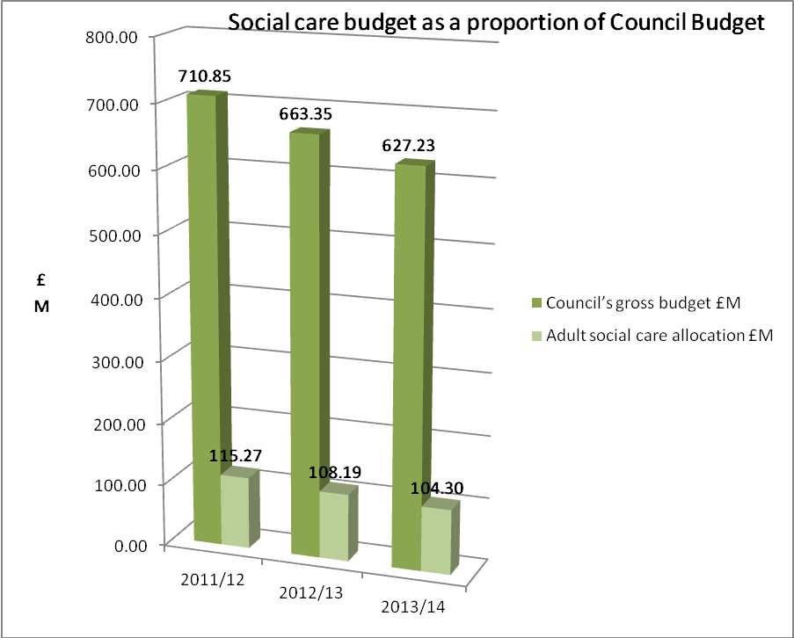

Financial year | Council’s gross budget (excluding internal recharges) | Adult social care allocation
2011/12 | £710.85m | £115.268m (16.22%)
2012/13 | £663.35m | £108.199m (16.31%)
2013/14 | £627.23m | £104.309m (16.63%).

Service user contributions through charges for services compared to gross budget

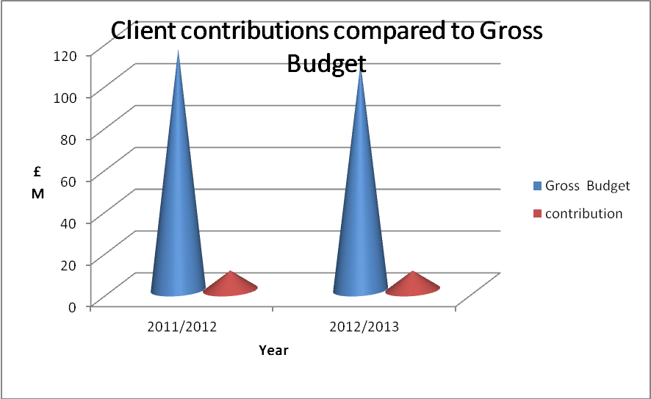

Financial year |  | Contribution
2011/12 | £115.268m | £9.253m
2012/13 | £108.199m | £9.193m
ADULT SAFEGUARDING FACTS AND FIGURES
In relation to individual concerns, during the year 2011/12 adult social care dealt with 784 referrals and concerns.
Of these:

- 160 related to people aged over 85
- 453 related to people with physical and sensory disabilities
- 94 came from family members and 174 from the health service
- 322 were for physical abuse, 129 for emotional abuse and 215 for neglect
- 366 cases of alleged abuse took place within people own homes and 336 within care homes
- 55 cases resulted in increased monitoring, in 15 cases adults were removed from the property
- 8 cases resulted in criminal prosecutions, 45 cases resulted in police action and 34 cases resulted in counselling, training or treatment
The concerns raised by these referrals ranged across all types of abuse:
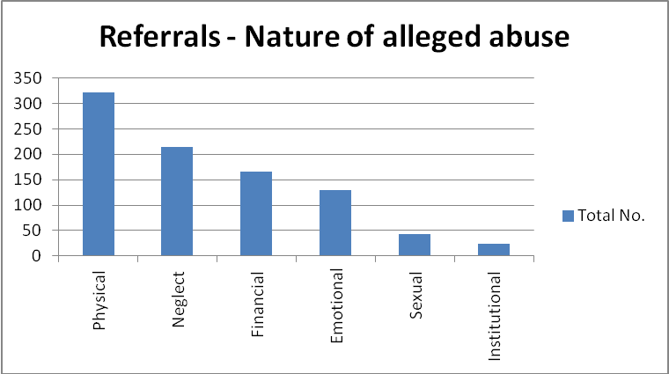
Adult safeguarding has also undertaken 35 complex/large scale adult safeguarding investigations where there are concerns about a residential/nursing or home care provider that involve several residents. These investigations involve close working with key partners such as health and police.
Walsall Council and partner agencies’ workforces are encouraged to undertake adult safeguarding training courses (run by Walsall Council) to ensure that they:
- Understand the different types of abuse and neglect
- Develop skills in recognising abuse
- Understand Walsall’s approach to safeguarding adults and the process for dealing with concerns and disclosure
- Are clear about their role and responsibility
- Think more proactively about the positive steps they can make individually and collectively to the prevention of abuse
- Consider the support systems in place for themselves and for people in the event of a disclosure of abuse by them or against them
During 2011-13 700 workers attended safeguarding awareness training courses, which are available to employees from within Walsall Council, partner agencies, the independent sector and Personal Assistants.

The learning outcomes of this training are that participants:

- Are able to consider what constitutes abuse
- Develop skills in recognising abuse
- Know how to efficiently apply the Whistle Blowing Code
- Are able to efficiently respond to abuse according to Walsall Council policy and procedures
- Are aware of the support systems in place for individuals involved in adult safeguarding investigations
- Identify ways of creating a safe environment for adults at risk and explore preventative strategies
- Are able to apply the programme learning to adult safeguarding situations
39 officers attended the more specialist training courses; chairing case conferences and investigative skills
OUR WORKFORCE

- 35% are aged between 46 and 55 whilst 5% are aged between 19 and 25
- 10% consider themselves to have a disability

DEVELOPING THE WORKFORCE

During 2011/12 a workforce development team was established within adult social care to be responsible for the learning and development needs of the social care workforce in Walsall, including carers, PAs, and those in the private, voluntary and independent sectors. The vision is for a World Class Workforce, drawn from all sections of the community who are capable, confident and skilled.

Following a detailed analysis of the learning and development needs of the workforce, a programme of learning was drawn up. The programme, whilst including core and mandatory elements, also includes a range of opportunities which underpin the principles of personalisation such as reablement awareness and telecare awareness. The programme is constantly evolving with the aim wherever possible of including individuals with specific conditions as co-deliverers of the training. An example of this is the sensory impairment training ‘Walk a Mile in my shoes’ and Autism Awareness.
As supervision and appraisal is central to developing and supporting the workforce to deliver the highest standards of care and support, the social work supervision policy has been refreshed and to date over 100 staff have been trained in its application. A number of performance indicators have also been established for workforce development which includes compliance with conducting supervision and appraisals. Training sessions in conducting appraisals will commence in June 2013.

USE OF OUR WEB PAGES AND HELP IN THE COMMUNITY PAGES

In 2011/12 more than 22,000 hits were made on the ‘Help in the Community’ web page which lists over 150 organisations and suggestions for individuals to gain the support they require within their local community.
In 2012/13 this decreased to around 5,000 hits. This decrease may be due in part to the reduced promotion of the web page and/or the inclusion of a number of other links overshadowing it on the main health and social care web page.
VIEWS OF LOCAL PEOPLE

During 2011/12 we received 147 complaints and 110 compliments about the services adult social care arranged or provided, whilst between 1 April 2012 and 31 March 2013 123 complaints and 149 compliments were received. Complaints received by service area during 2011/12 and 2012/13 are shown below:

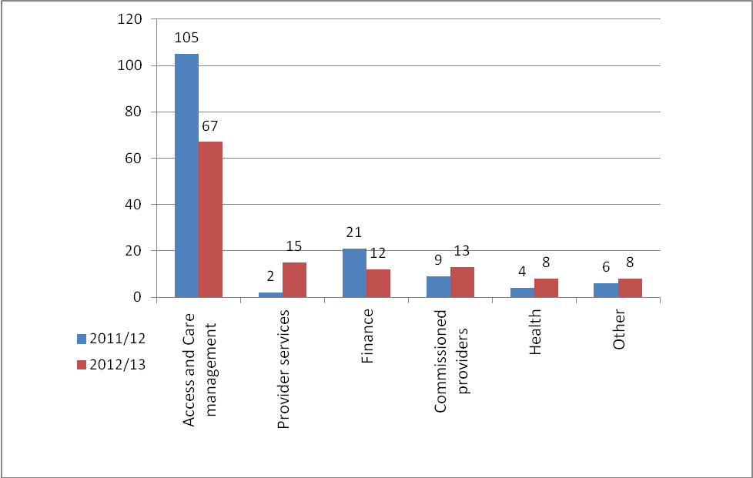

From the council’s 2011/12 survey of 1,000 adult social care service users in Walsall:

- 36% (485 respondents) were very satisfied with the social care services they receive compared to an average of 35% in England
- 73% (70) are very happy with the support they receive from staff (England average 72%)
- 30% (475) feel their quality of life is good (England average 29%)
- 46% (560) feel that they have adequate control over their daily life (England average 45%)
- 84% (540) thought that care services in Walsall kept them clean and presentable (England average 71%)
- 66% (550) felt their home was clean and comfortable due to the support they received (England average 64%)
- 61% (545) thought the way they are helped and treated makes them feel better about themselves (England average 59%)
- 69% (550) said that they feel as safe as they wanted to (England average 64%)

We recognise that we need to

- Make it easier for people to find information and advice about support services and benefits as only 19% of users felt they could compared to 20% in England (535 respondents)
- Provide better ways of enabling people to get to the places they want to (28% felt they could compared to 30% in England).

CASE STUDIES
Enhancing the quality of life for people with care and support needs

Personal Budget helped me get the support I needed
Mrs P has dementia and used to attend a day centre. She decided to stop going as she wasn’t enjoying it and wanted to get out and meet her friends and more people.
Her Personal Budget has given her the freedom to do the things she wants to do. She now goes to bingo every Wednesday, escorted by her next door neighbour and attends the Frank F Harrison Centre twice a week, which she enjoys because her best friend attends as well.
Since she’s had her Personal Budget Mrs P feels that she is more confident and doesn’t need a visit from a carer each evening. She uses an alarm pendant, alongside other equipment, to enable her to be more independent around her home.
Every Sunday she is assisted in preparing her roast dinner and food for the week ahead. She used to find it difficult attending medical appointments, in particular remembering the instructions given to her. Her personal assistant, funded from her Personal Budget, now attends appointments with her so they are aware of the instructions given and to give her the security that she is following the advice correctly. As well as her bingo trips, her personal assistant takes her out shopping once a week. She now has a variety of activities to look forward to and no longer feels so lonely and isolated.
Mrs P has a life book which allows her to express her wishes and to retain for her own records should her memory deteriorate to a point where others need to make decisions on her behalf. This book identifies where she keeps her personal records for her family and what she does and doesn’t want to happen in the future.
All this is a great outcome for Mrs P. She’s more engaged with the local community and leading a more fulfilling and rewarding life, and her support costs have reduced.
Thirty years of caring – respite makes such a difference

Meals out, holiday plans and shopping trips are things most people take for granted but Linda can’t accept any of these invitations without meticulous planning. Her first priority is her daughter Lindsey who has learning disabilities and needs constant supervision.

Linda and her husband Brian, who live in Bloxwich, recall one wonderful night out, round a friend’s house, when Lindsey came along too and happily sat down with everyone. “We’d had a lovely night and were just getting our coats when Lindsey ran past us, up the stairs and started to wreck their bathroom,” said Linda. “And I do mean wreck. She managed to remove the cistern and smash it up.
“Our friends still remember how pale I went in the split second that we realised she had got past us. But I knew exactly what to expect as she has done the same thing at home. “As part of her condition, which we have never been given a diagnosis for, she can fly into terrible tempers and rages and we know from years of experience that she needs to get this out of her system before she can settle.”
Linda is 30 years-old and doctors have said they believe she has some of the characteristics of autism. She doesn’t speak but can communicate using the Makaton method to say when she wants a drink or to go to the toilet. She also attends the Goscote Centre every day, which she loves.  “Unless you are or have been a carer, you can’t understand how this affects the life of a family,” said Linda, 60. “You have to be totally switched on and alert regardless of the fact you haven’t had a wink of sleep the night before. | 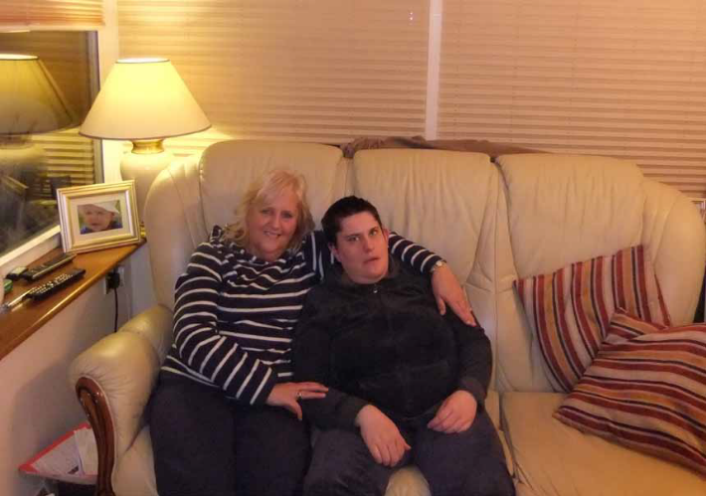

“Of course we all care for our children but when they have a disability it’s a completely different matter.” Linda also explained that things had been very hard for the couple’s younger daughter Leanne. “All our attention has been focused on Lindsey’s needs.”
Linda said she welcomed the work on an updated Carers’ Strategy. “It’s a good idea because the thing that carers want most is to be listened to,” she said. “We want people - and professionals - to really understand what our lives are like, and I mean really understand. “We also want other carers who may be called upon to look after our loved ones to be as near a match to us as possible. Too many people seem to see the role of a carer as “just a job” and that’s not good enough.
“I know there is only a certain amount of money but respite makes such a difference to the carer and to the person being cared for,” she said. “We are here 365 nights of the year so any respite makes the world of difference. Lindsey goes to respite in Sutton Coldfield and we know she is safe and being well looked after as she has one to one care there. “She loves going and it gives Brian and I the opportunity to perhaps go out for a meal or if nothing else have an uninterrupted night’s sleep. “We can’t just ask relatives or friends to care for Lindsey because she is so demanding and we know they wouldn’t be able to cope.
“I’m sure many carers would say they would like to see more respite facilities provided in Walsall. It’s a lifeline to so many and helps families recharge their batteries so they can keep going in a very demanding role.”
Giving it a go - activities for workers with disabilities
Our Links to Work supported employment programme proves that people with disabilities can earn and contribute to the economy.
 | Workers at a factory in Willenhall all have one thing in common – but as they go about their business of cleaning, packing, sorting, labelling and assembly it isn’t necessarily obvious what that is. They all seem genuinely delighted to be at work and they all enjoy a laugh and a joke as they get things done. So they share a real camaraderie.  They also all have a disability or health condition but are determined that this does not get in the way of them living their lives.
Karl, aged 33, uses a wheelchair after being struck by a lorry. He employs a Personal Assistant, Chris, to support him while he’s at work. Karl, who lives in Cannock, cleans telehealth equipment which is used by people with long term conditions such as heart disease, respiratory illnesses, arthritis and dementia, to monitor their conditions while remaining independent at home.

“I love it here,” said Karl. I clean the equipment and go and work on the computer as well.” Karl hopes other people with disabilities will feel encouraged to go to work, “they should have a go because you can make friends as well.”

Ann of Bloxwich has just one thing to say to people who are wondering whether to take the plunge into work – “Give it a go!” Ann has epilepsy which she controls with medication, and she seals plastic packs of screws for DIY stores. “I like the people I work with and the staff here,” said the 59-year-old.

Up to 60 people a day are busy at Links To Work regardless of having mental health issues, learning disabilities, physical disabilities or being deaf-blind.

Apprenticeships Work
Andrew is 23 years old and has successfully gained employment with Walsall Council as an Apprentice Reablement Officer. Andrew started his employment in February 2012 and is currently deployed to Day Opportunities, specifically Recruitability Plus (Links to Work).
For 6 months Links to Work provided excellent work preparation and a ‘Stepping Stone’ for Andrew, which culminated in a work placement with Walsall Housing Group for 6 months, also organised by Links to Work.

Following attendance at Walsall College and a period of employment (fixed term contract) Andrew has returned to Links to Work as a Walsall Council employee.
Andrew has expressed that ‘I am really enjoying my Apprenticeship, supporting me with building confidence and character development’.
Andrew will be working in other areas of adult social care to complete his 2 Year Apprenticeship. This will enable him to develop knowledge and experience which should put him in a good position for seeking future employment in the health and social care sector.
Our Summer Scheme is a winner
Our summer scheme gives members of the community opportunities to volunteer and help members of their local community.
Jerome has a learning disability but he is determined to get the most out of life and encourages others to do the same. As a result of his enthusiasm and his warm rapport with fellow football fans, he hopes to teach football coaching at next year’s Walsall Learning Disability Summer Scheme. Donna Smith, Walsall Council community project manager, said: “Jerome is a fantastic mentor as he loves football and that enthusiasm really comes across.”
Just a few years ago Rob was heading for one place only – prison. He freely admits he was “off the rails” and struggling to cope with difficulties at home while trying to care for his father. “Every time anyone tried to have a conversation with me I’d tell them where to go and swore all the time,” he explained.
Looking at Rob today, at the age of 23, as he supports adults with learning disabilities on a summer scheme in Walsall, it’s hard to believe he was ever anything but patient and understanding. As he has a learning disability himself, he appreciates the needs of the group. “I like organising people and helping them to get the best out of things and I think they see that in me,” said Rob.

Rob added: “I had really fallen into a bad crowd and I would have ended up in prison - there’s no doubt about it. Volunteering has helped me to change and I can cope with life much better. I would never go back to the old me.”

Delaying and reducing the need for care and support

Confidence with Telehealth

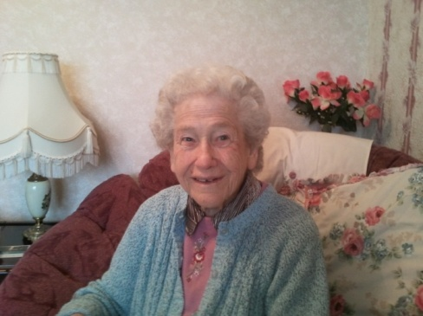 | Emily is 88 years old and lives in Walsall. She was diagnosed with heart failure in 2000 and has been re-admitted several times to Walsall Manor Hospital.  During one of her stays in hospital Emily was introduced to Telehealth by an acute cardiac nurse who explained how it could benefit her.

Before Telehealth was installed Emily used to worry more and more about her condition which could then make her anxious. She now feels that Telehealth has provided her with peace-of-mind. “Just knowing that somebody is there to check my reading gives me so much confidence, and the confidence takes the worry away.” This reassurance also extends to Emily’s family and friends. “My son thinks that Telehealth is a brilliant idea and is all for it. It means he doesn’t have to worry about me as much because my readings are being regularly checked by the nurses.”

“I would 100% recommend Telehealth to anybody. I think that if everybody like me had a Telehealth monitor it would save so much expense in the long run and bring care into the home.” “Telehealth gives me a sense of my own independence. I feel like I am not on my own. I’m thrilled to bits with it.”

Free peace of mind for Walsall’s octogenarians … and nonagenarians and centenarians

Walsall Council’s decision to provide free Telecare for people aged 80 and over is making older people feel less vulnerable and more secure.

Walsall residents aged 80 and over are being reminded that they can have technology fitted in their homes completely free of charge to help them continue to live happily and independently in their communities.
In 2011 the Council approved the move to offer free community alarms to the borough’s most vulnerable people. Since then, Social care have been working to provide pendant alarms for people to press if they have a fall or feel unwell, along with smoke detectors which are monitored directly by the Community Alarm Service. Residents have also had secure key safes fitted which mean access can be gained to their homes speedily in an emergency.

Grandmother Alice Plant, aged 86, has just had Telecare installed at her home near Walsall. “I think Walsall Council is really looking after the elderly with this,” she said. “I’ve got a wonderful family who visit me every day and help me but if I was to have a fall or anything I can’t get help quickly. I think it’s great and would tell others of my age to get them sorted out – it’s not costing me a penny”. | 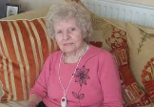
Baking Cakes – an example of reablement
A busy successful housewife all her life, Mrs J ran her household in Aldridge looking after her husband and children for many years, living with a visual impairment from an early age. Mr J began to take on more of the domestic duties when he retired, specifically cooking, in order to give Mrs J a break.
This arrangement was working fine until Mr J developed health problems which meant that he had to have double knee replacement surgery leaving him unable to look after his wife.
Mrs J had effectively stopped cooking, and had experienced a further reduction in how much she could see. Having to suddenly cook again in a kitchen she was no longer familiar with, both for herself and her husband, seemed like an impossible task. She did not think she would be able to cope. This was not a difficult situation for her: it was a crisis.
Following involvement by Rehabilitation Officers, the visual impairment team began to work closely with Mrs J to help her learn new skills, adapt skills she already had and gradually build up her confidence. Her progress was analysed and after each session her achievements were highlighted and her confidence grew as a result.
Mrs J’s last session was making a cake – a complex task. When the Rehab Officer arrived he found Mrs J in her kitchen with a cake she’d baked on her own, a card thanking him for his help, and a cup of coffee. She told him, “Thank you, your work is all done now.” Our rehab officer could only agree, and have his cake, and eat it!
The power of community
Following a piece of work to ensure that they knew how to manage a bank account and their money, and the importance of remembering and keeping PIN numbers secret, Mr and Mrs Y chose to manage their own finances. The Social Worker and the Welfare Rights Officer assisted them to take control and open their own bank account, allowing them to manage their own money independently.
Once the account was set up, the Neighbourhood Community Officer Service supported Mr & Mrs Y with shopping independently, collecting money and developing a pictorial calendar in partnership with the Person Centred Planning service. The KeyRing network then offered support to help Mr & Mrs Y regain their independence with cleaning tasks around the home and helping to sort out paperwork and filing.

Having expressed a wish to work, a referral was made to the Council’s positive action scheme for people with a learning disability – Recruitability Plus. They both found jobs working in local leisure centres and the Welfare Rights Officer supported them by making sure pre-employment checks/documentation were available, including CRB checks.

Now that Mr & Mrs Y no longer require support from the Social Worker, Welfare Rights or the Reablement Officers, KeyRing is the only agency involved.
Ensuring that people have a positive experience of care

Greenacres project continues to bloom

Our Goscote Greenacres site is a joint initiative between Walsall Council adults’ social care, Walsall Adult and Community College, North Walsall Area Partnership and others supporting people with disabilities and the wider community.

 | The project is being created in the grounds of the Goscote Centre which is used by adults with disabilities and is being driven by them, their carers and the wider community. It will feature a market garden, sensory garden and café. Creative enterprise potential and recycling are also among the opportunities that could be created.
Robert attends the Goscote Centre and is known for his huge smile. He is involved with the gardening, which he thoroughly enjoys and said he approves of the new project.

A new training kitchen has been established at the centre and a new breakfast club caters for local workers, neighbours and shoppers grabbing an early morning bite to eat. Some people with learning disabilities will be able to use the new kitchen to receive catering training to gain qualifications and employment. A new conservatory has also been added on to the centre’s dining room, and a hair and beauty salon has been created as a facility for the centre’s users as well as neighbouring residents.

Stuart’s feeling “fantastique” about his new life
Our KeyRing supported living networks are proving that it is possible to leave residential care and live back in the community with a support network.
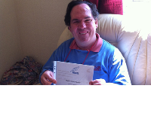 | With French classes, a love of cookery, regular trips to his local library and his sights set on getting a job, Stuart Parker thinks his life is pretty good. But it was a different story just a few years ago as Stuart struggled to manage his epilepsy and really felt his life was getting out of control. Now he lives in a KeyRing-supported property near to Walsall and is thoroughly enjoying his independence.

Stuart, aged 36, explains: “I was in a residential home in my twenties because my condition wasn’t under control enough. It took a while to get my tablets sorted out and I had some difficult times while this was going on. But since everything has been sorted out things are much better.
“I moved into my new flat last year and it’s good that I could choose my carpets and wallpaper for myself. I love cooking which my mum has been helping me with. She has explained how to do different recipes and I have been learning with her. I like Italian food the best.”
Stuart’s social worker Amanda Benton says she is very proud of the progress he has made. “Stuart’s growing cooking skills mean that he is telling his carers how to cook and sharing his expertise now”. “While he has had difficulties in the past because of his condition, he is now going from strength to strength and is a good example for other people to see what can be achieved.
Stuart continues to live independently and is now undertaking voluntary work at the disco and local drama group. He visits his mom regularly and has maximised the use of assistive technology at home. He enjoys browsing the web on his I-Pad and is currently looking at new courses to enrol on next term at college.
Quality matters
Quality assurance became involved with a care home following intervention from the Infection Prevention and Control service that had visited the home and identified a range of issues including cleanliness, equipment and staff training, as well as concerns about the care being provided to residents. As a result, the council temporarily stopped placements to the home.
Quality assurance and infection control worked with the home to develop a detailed action plan to improve the cleanliness of the home and the quality of care to residents. The action plan was reviewed two months later. Managers, staff and residents at the home were very positive and could see evidence of a number of improvements including new equipment, infection control training delivered to staff, new cleaning schedule in place – including weekly audits and spot checks and carpets and flooring being replaced
As a result of the involvement of quality assurance alongside partner agencies, a home that had a number of serious issues has taken ownership of these issues and made significant progress in only a few months to enable their suspension to be lifted and allow them to deliver an improving service.
Extra Care Housing Scheme increases confidence and independence

X is an older person with learning disabilities. She had lived in residential care for most of her adult life and at the same home for over 20 years. She and her family had previously been unwilling to consider any alternatives because of her understandable fear of change and their doubt as to whether her needs could be met in any other way.
Using the self directed support process we helped X to think about other ways by which her needs could be met and how she could achieve the results she wanted out of life. A support plan was completed and she moved from residential care into an Extra Care housing scheme with some support. She now attends a work placement and a day service for activities that she enjoys.
Although initially apprehensive about the changes in X’s life, her family now tell us that these are very positive and that X has blossomed since moving into her own tenancy.
X now has access to benefits which have given her new opportunities for her, for example she has commented that she is now able to buy new rather than second hand clothes. She has more confidence and independence which has resulted in some of her support no longer being required. It has also been noticed that she now appears happy, and has a real sense of humour – things that could not be said about her when she was in residential care.
Some of X’s friends in the same residential home initially declined the opportunity to move into the same Extra Care scheme, but after seeing the success of X’s move, some of them thought again and also moved into extra care. One older person had lived in numerous institutions including hospitals and residential homes from a very young age. Understandably, her family doubted that she could cope in the community having lived all of her life in residential establishments. But she is now living in her own tenancy, accesses advocacy groups, work placement, and has a part time job as a volunteer.
In addition to belonging to the tenants association at the Extra Care scheme, the people whose stories are outlined above have also formed their own support group with other tenants, where they receive support and attend weekly meetings with a support worker who provides the extra support they need, including helping them to plan activities, community visits and holidays. Their lives have been transformed.
Safeguarding adults whose circumstances make them vulnerable and protecting them from avoidable harm
The Adult Safeguarding Unit kept me safe
J is a lady in her early 80s. She lives alone and her mobility has become increasingly difficult. Macular degeneration means that her sight is deteriorating and has become very poor. Despite these difficulties, J has capacity to make all decisions and choices about her life. J is adamant that she wants to remain in her own home, and feels that she can manage with daily support from carers. Her family only visit at weekends, but maintain contact with her regularly.
J’s daughter attended a presentation about safeguarding adults at her local community group and kept the leaflet that she was given. Following the presentation, J’s daughter thought that she would check on her mother’s finances; asking her how this was being handled.
J’s mother explained to her daughter that one of the carers from the agency would come back after her normal shift, take her bank card, go to the cash machine and take money out then get any shopping that she needed. J felt that this was very kind of the worker and was most grateful for the help. J explained to her daughter that she had not looked at her bank statements for quite a while as her sight was not now good enough to see them. However, when her daughter checked, there were no bank statements in the house - her mother thought that the carer must have tidied them away. Her daughter then checked her mother’s bank balance on line and then with the bank, and discovered that over £5,000 had been withdrawn over the last six months.
Mrs J’s daughter immediately contacted the telephone number on the adult safeguarding leaflet she had kept and the matter was dealt with as a safeguarding investigation by the adult safeguarding unit. The investigation was led by the police and the carer was discovered to have been doing something similar to two other service users. The carer was prosecuted and dismissed from her job.
Following these interventions by the adult safeguarding unit, Mrs J’s daughter now helps her mother to collect her money and gets her shopping.

For more first hand stories about social care have a read of our Who Cares? blog.

