Physical activity in parks

Commercial operators licence

Application form

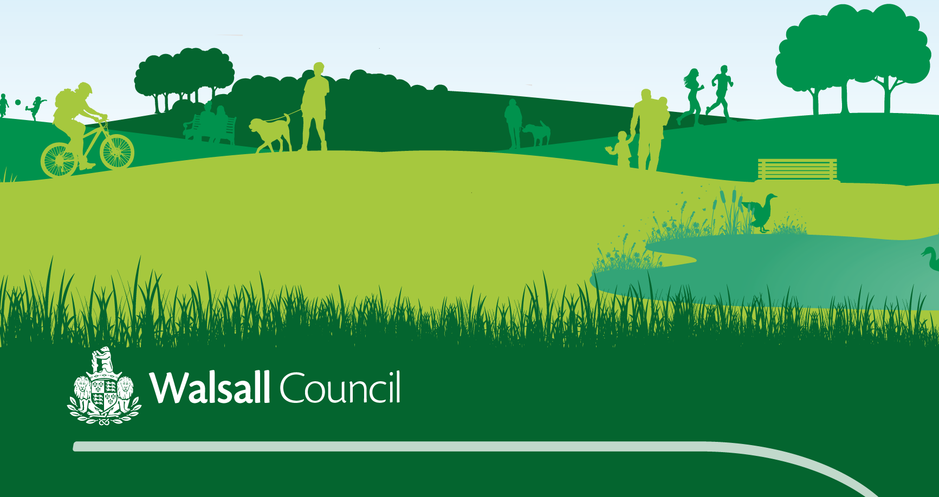

Those wishing to deliver organised commercial or profitable activity (such as personal trainers and bootcamps) in parks and greenspaces, must seek permissions and the appropriate licensing from the relevant local authority (the landowner).

This licence safeguards your organisation as a reputable, qualified and insured training provider, and allows us as a council to market and promote your session to the wider community.

There are three options for charges to use our park sites to deliver sessions

**Option 1** – The group is charged £75 per quarter for park hire to run the sessions independently. This means they can charge whatever price they choose to users.

**Option 2** – If the session is free to participants there will be no charge for park hire.

**Option 3** – The group can choose to be part of our borough wide programme of activities under the umbrella of the Healthy Spaces Team. For this the group will get free park hire but they will be expected to collect data from their participants which is sent back to the Healthy Spaces Team on a regular basis.

Wider conditions of the licence

* Ensure Activities do not impact on wider council activities, other approved activities or the public in general.
* Training activities are conducted at all times upon the area in a manner which is not an annoyance, nuisance or disturbance to other users of the facility including other trainers and nearby residents.
* Be conscious of keeping noise levels to a minimum, particularly in the evening
* Ensure the facilities are left clean and tidy
* Those involved in fitness activities must not use picnic tables, seating, street furniture, fences, walls, shade shelters, trees or other structures as training aids and must not damage any natural assets such as dressed areas, vegetation, trees, shrubs and the like.
* Training providers may provide appropriate equipment / fitness aides for fitness activities and such equipment shall be in good order and repair. Heavy equipment that may damage the environment in which it is used is not permitted.

Accreditation

* All training providers and fitness instructors should have and maintain appropriate suitable qualifications with the following minimum expectations
* Accredited as a fitness trainer / coach specific to the type of activity to be conducted; and
* A current first aid certificate

# SECTION ONE - ORGANISER DETAILS

Name of organisation: Click or tap here to enter text.

Organiser: Click or tap here to enter text.

Deliverer / coach / instructor: Click or tap here to enter text.

Contact address: Click or tap here to enter text.

Postcode: Click or tap here to enter text.

Tel No (work / home): .Click or tap here to enter text.

Tel No (mob): Click or tap here to enter text.

Fax No: Click or tap here to enter text.

E mail address: Click or tap here to enter text.

Social media pages / links: Click or tap here to enter text.

# SECTION TWO - ACTIVITY DETAILS

**NAME OF SESSION / s:** Click or tap here to enter text.

Venue / s: Click or tap here to enter text.

Date from / to: Click or tap here to enter text.

Description of proposed activity: Click or tap here to enter text.

Is this a (please tick relevant box)

Commercial session/event  Charity session/event

Days and times of delivery

|  |  |  |  |  |  |  |  |
| --- | --- | --- | --- | --- | --- | --- | --- |
|  | **Monday** | **Tuesday** | **Wednesday** | **Thursday** | **Friday** | **Saturday** | **Sunday** |
| Time | Click or tap here to enter text. | Click or tap here to enter text. | Click or tap here to enter text. | Click or tap here to enter text. | Click or tap here to enter text. | Click or tap here to enter text. | Click or tap here to enter text. |
| Time | Click or tap here to enter text. | Click or tap here to enter text. | Click or tap here to enter text. | Click or tap here to enter text. | Click or tap here to enter text. | Click or tap here to enter text. | Click or tap here to enter text. |
| Time | Click or tap here to enter text. | Click or tap here to enter text. | Click or tap here to enter text. | Click or tap here to enter text. | Click or tap here to enter text. | Click or tap here to enter text. | Click or tap here to enter text. |
| Time | Click or tap here to enter text. | Click or tap here to enter text. | Click or tap here to enter text. | Click or tap here to enter text. | Click or tap here to enter text. | Click or tap here to enter text. | Click or tap here to enter text. |

Approximate number of people expected to attend: Click or tap here to enter text.

Is there a cost to the participant? Click or tap here to select Yes or No

If yes, how much? Click or tap here to enter text.

# SECTION THREE – KEY DELIVERY SAFETY CHECKLIST

To register an activity delivered for **adult (16+) participation** please complete sections **A, B and D**

To register an activity for **junior (under 16) participation** please complete sections **A, C and D**

For activities which are open to both **adults and juniors** please complete sections **A, B, C and D**

# Section A: Essential criteria for all activities

* **Are you insured?** Please attach a copy of your public liability insurance of at least £2 million. *(the council reserves the right to require a higher level of cover if deemed necessary).*
* **Are you equitable?** We are committed to the promotion of equality and diversity regardless of age, gender, disability, religion or cultural background. *Tick to agree*
* **Emergency Plan** - Is there an emergency plan in place?  
  *If yes please enclose copies*

Click or tap here to select Yes or No

* **Risk Assessments** – have risk assessments been completed for the delivery?*If yes please enclose copies*

Click or tap here to select Yes or No

* **Litter collection** - please state how you will maintain the park free of litter and rubbish during the session and after it has finished.

Click or tap here to enter text.

# Section B: Activities for adults (16+)

* **Are your participants safe?** Please state what first aid provision is in place for the activity:

Click or tap here to enter text.

**Is the activity coached or instructed?** Click or tap here to select Yes or NoIf yes, please list delivery qualifications and awarding bodies that staff hold to cover your delivery:

|  |  |
| --- | --- |
| Qualification type / level | Awarding body |
| Click or tap here to enter text. | Click or tap here to enter text. |
| Click or tap here to enter text. | Click or tap here to enter text. |
| Click or tap here to enter text. | Click or tap here to enter text. |

* **Is the activity likely to regularly provide opportunities to vulnerable adults?** If yes, please confirm that a DBS check has been completed for all deliverers  **Yes**  **No** ¨ **N/A**

# Section C: Activities for juniors (under 16)

* **Are your participants safe?** Please state what first aid provision is in place for the activity:  
    
   Click or tap here to enter text.

Please tick to confirm that you record the emergency contact details and any medical conditions of the children under your supervision

* **Are relevant DBS checks in place?** All people regularly involved in the delivery or organisation of junior activities should have a DBS check at appropriate levels. Please confirm that a DBS check has been completed for all deliverers  **Yes**  **No**

Are arrangements in place for checks and renewals?  **Yes**  **No**

* **Are coaches or instructors suitably qualified to deliver the activity?** Please list delivery qualifications and awarding bodies that staff obtain for your delivery:

|  |  |
| --- | --- |
| Qualification type / level | Awarding body |
| Click or tap here to enter text. | Click or tap here to enter text. |
| Click or tap here to enter text. | Click or tap here to enter text. |
| Click or tap here to enter text. | Click or tap here to enter text. |
| Click or tap here to enter text. | Click or tap here to enter text. |
| Click or tap here to enter text. | Click or tap here to enter text. |

* **Is there a suitable child protection policy and procedures in place?**

Please tick to confirm that all people involved in the delivery or organisation of the activity are aware of how and where to report a child protection issue

# Section D – Charging Options

Please tick which one of the following charging options you wish to take.

**Option 1** – £75 per quarter. Charge whatever price you choose to users.

**Option 2** – Free - If the session is free to participants.

**Option 3** – Free - If you submit data to the Healthy Spaces Team. Charge whatever price you choose

Data is needed monthly, for both “number of **participants”** and “total number of **attendances**”

* **Participant** – If one person attends for four sessions, they are one participant.
* **Attendances** – If one person attends for four sessions, they have attended four times

Once a year we will request a rough breakdown of percentage of attendees in terms of

* Gender
* Ethnicity
* Disability
* Age bandings (Under 18 / 18 – 30 / 31 – 50 / 50 plus)

# Section E: Declaration

I must notify the Healthy Spaces Team if I have any safeguarding concerns about my group/ organisation’s lack of adherence to an effective safeguarding policy (this applies if you are providing services for children under 18 and / or vulnerable adults).

I will undertake to inform the above if I, or my organisation / group have any concerns about any adult associated with the activity in respect of safeguarding.

I understand that failure to do so could result in a termination of the agreement.

I will ensure there are signing in / signing out arrangements, to ensure that those using the premises / sites have vacated at the end of the session.

If I have chosen to take the option of free park usage under the umbrella of Healthy spaces activities I will provide Walsall Council with participation figures at the end of each month on the agreed template, and a yearly overview of group demographics.

I confirm that all the information provided by myself, or my organisation in the form above is accurate.

Signed



Name in Block Capitals Click or tap here to enter text.

Position in Organisation. Click or tap here to enter text.

Date Click or tap to enter a date.

Please send this completed form, together with all supporting documentation to: [healthyspaces@walsall.gov.uk](mailto:healthyspaces@walsall.gov.uk)

**Office use only**

Building / Site induction undertaken? ¨ **Yes** ¨ **No**

Healthy Space Staff sign / date to confirm when completed: …………………………………………………………………………………

Confirmation of documents seen:

For more information please contact the Healthy Spaces Team on   
01922 653344

200 Pelsall Lane

Brownhills

Walsall

WS8 7EN.